**Fishery Manuscript No. 20-XX**

**Escapement Goal Review of Copper and Bering Rivers, and Prince William Sound Pacific Salmon Stocks, 2020**

**by**

**Philip J. Joy**

**Stormy B. Haught**

**Richard E. Brenner**

**Sara Miller**

**Jack W. Erickson**

**James W. Savereide**

**and**

**Timothy R. McKinley**

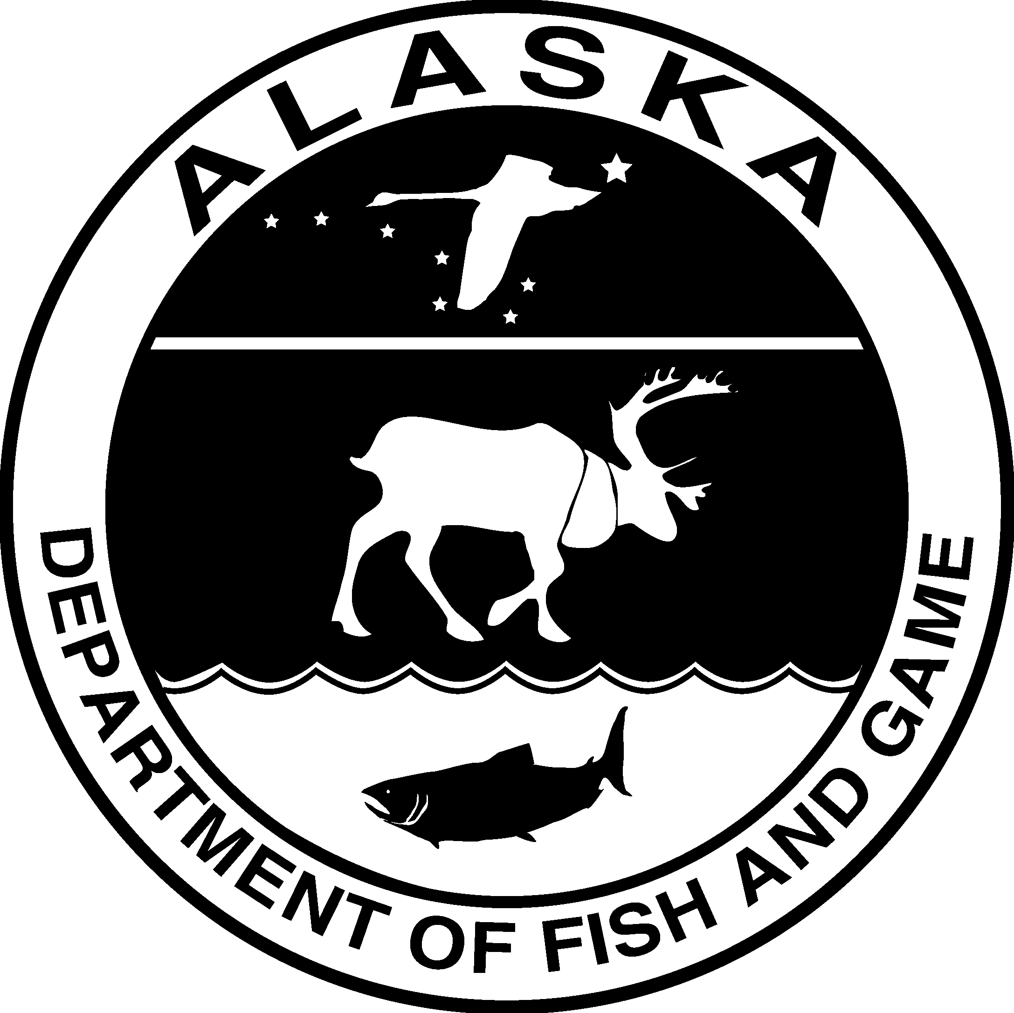

**XXXX 2020**

**Alaska Department of Fish and Game Divisions of Sport Fish and Commercial Fisheries**

Symbols and Abbreviations

The following symbols and abbreviations, and others approved for the Système International d'Unités (SI), are used without definition in the following reports by the Divisions of Sport Fish and of Commercial Fisheries: Fishery Manuscripts, Fishery Data Series Reports, Fishery Management Reports, and Special Publications. All others, including deviations from definitions listed below, are noted in the text at first mention, as well as in the titles or footnotes of tables, and in figure or figure captions.

**Weights and measures (metric)**

centimeter cm

deciliter dL

gram g

hectare ha

kilogram kg

kilometer km

liter L

meter m

milliliter mL

millimeter mm

**Weights and measures (English)**

cubic feet per second ft3/s

foot ft

gallon gal

inch in

mile mi

nautical mile nmi

ounce oz

pound lb

quart qt

yard yd

**Time and temperature**

day d

degrees Celsius °C

degrees Fahrenheit °F

degrees kelvin K

hour h

minute min

second s

**Physics and chemistry**

all atomic symbols

alternating current AC

ampere A

calorie cal

direct current DC

hertz Hz

horsepower hp

hydrogen ion activity pH

(negative log of)

parts per million ppm

parts per thousand ppt,

‰

volts V

watts W

**General**

Alaska Administrative

Code AAC

all commonly accepted

abbreviations e.g., Mr., Mrs., AM, PM, etc.

all commonly accepted

professional titles e.g., Dr., Ph.D.,

R.N., etc.

at @

compass directions:

east E

north N

south S

west W

copyright ©

corporate suffixes:

Company Co.

Corporation Corp.

Incorporated Inc.

Limited Ltd.

District of Columbia D.C.

et alii (and others) et al.

et cetera (and so forth) etc.

exempli gratia

(for example) e.g.

Federal Information

Code FIC

id est (that is) i.e.

latitude or longitude lat. or long.

monetary symbols

(U.S.) $, ¢

months (tables and

figures): first three

letters Jan,...,Dec

registered trademark ®

trademark ™

United States

(adjective) U.S.

United States of

America (noun) USA

U.S.C. United States Code

U.S. state use two-letter abbreviations (e.g., AK, WA)

**Measures (fisheries)**

fork length FL

mideye-to-fork MEF

mideye-to-tail-fork METF

standard length SL

total length TL

**Mathematics, statistics**

*all standard mathematical*

*signs, symbols and*

*abbreviations*

alternate hypothesis HA

base of natural logarithm *e*

catch per unit effort CPUE

coefficient of variation CV

common test statistics (F, t, χ2, etc.)

confidence interval CI

correlation coefficient

(multiple) R

correlation coefficient

(simple) r

covariance cov

degree (angular ) °

degrees of freedom df

expected value *E*

greater than >

greater than or equal to ≥

harvest per unit effort HPUE

less than <

less than or equal to ≤

logarithm (natural) ln

logarithm (base 10) log

logarithm (specify base) log2, etc.

minute (angular) '

not significant NS

null hypothesis HO

percent %

probability P

probability of a type I error

(rejection of the null

hypothesis when true) α

probability of a type II error

(acceptance of the null

hypothesis when false) β

second (angular) "

standard deviation SD

standard error SE

variance

population Var

sample var

***FISHERY MANUSCRIPT NO. XX-XX***

**ESCAPEMENT GOAL REVIEW OF COPPER AND BERING RIVERS, AND PRINCE WILLIAM SOUND PACIFIC SALMON STOCKS, 2020**

by

Philip J. Joy

Alaska Department of Fish and Game, Division of Sport Fish, Fairbanks

Stormy B. Haught

Alaska Department of Fish and Game, Division of Commercial Fisheries, Cordova

Richard E. Brenner

Alaska Department of Fish and Game, Division of Commercial Fisheries, Juneau

Sara Miller

Alaska Department of Fish and Game, Division of Commercial Fisheries, Juneau

Jack W. Erickson,

Alaska Department of Fish and Game, Division of Commercial Fisheries, Anchorage

James W. Savereide

Alaska Department of Fish and Game, Division of Sport Fish, Fairbanks

and

Timothy R. McKinley

Alaska Department of Fish and Game, Division of Sport Fish, Anchorage

Alaska Department of Fish and Game

Division of Sport Fish, Research and Technical Services 333 Raspberry Road, Anchorage, Alaska, 99518-1565

XXX 2020

The Fishery Manuscript Series was established in 1987 by the Division of Sport Fish for the publication of technically oriented results of several years’ work undertaken on a project to address common objectives, provide an overview of work undertaken through multiple projects to address specific research or management goal(s), or new and/or highly technical methods, and became a joint divisional series in 2004 with the Division of Commercial Fisheries. Fishery Manuscripts are intended for fishery and other technical professionals. Fishery Manuscripts are available through the Alaska State Library and on the Internet: [http://www.adfg.alaska.gov/sf/publications/.](http://www.adfg.alaska.gov/sf/publications/) This publication has undergone editorial and peer review.

*Philip J. Joy*

*Alaska Department of Fish and Game, Division of Sport Fish, Fairbanks*

*1300 College Road, Fairbanks AK, 99701, USA*

*Stormy B. Haught*

*Alaska Department of Fish and Game, Division of Commercial Fisheries, 401 Railroad Avenue, Cordova, AK 99574, USA*

*Richard E. Brenner*

*Alaska Department of Fish and Game, Division of Commercial Fisheries, 1255 W. 8th Street, Juneau, AK 99802, USA*

*Sara Miller*

*Alaska Department of Fish and Game, Division of Commercial Fisheries,*

*1255 W. 8th Street, Juneau, AK 99802, USA*

*Jack W. Erickson*

*Alaska Department of Fish and Game, Division of Commercial Fisheries, 333 Raspberry Road, Anchorage, AK 99518, USA*

*James W. Savereide*

*Alaska Department of Fish and Game, Division of Sport Fish, 1300 College Road, Fairbanks AK, 99701, USA*

and

*Timothy R. McKinley*

*Alaska Department of Fish and Game, Division of Commercial Fisheries, 333 Raspberry Road, Anchorage, AK 99518, USA*

*This document should be cited as follows:*

*Joy, P. J., S. B. Haught, R. E. Brenner, S. Miller, J. W. Erickson, J. W. Savereide, and T. R. McKinley. 2020. Escapement goal review of Copper and Bering rivers, and Prince William Sound Pacific salmon stocks, 2020. Alaska Department of Fish and Game, Fishery Manuscript No. 20-XX, Anchorage.*

The Alaska Department of Fish and Game administers all programs and activities free from discrimination based on race, color, national origin, age, sex, religion, marital status, pregnancy, parenthood, or disability. The department administers all programs and activities in compliance with Title VI of the Civil Rights Act of 1964, Section 504 of the Rehabilitation Act of 1973, Title II of the Americans with Disabilities Act of 1990, the Age Discrimination Act of 1975, and Title IX of the Education Amendments of 1972.

**If you believe you have been discriminated against in any program, activity, or facility please write:**

ADF&G, P.O. Box 25526, Juneau, AK 99802-5526

U.S. Fish and Wildlife Service, 4040 N. Fairfax Drive, Suite 300 Webb, Arlington, VA 22203

Office of Equal Opportunity, U.S. Department of the Interior, Washington DC 20240.

The department’s ADA Coordinator can be reached via phone at the following numbers:

(VOICE) 907-465-6077, (Statewide Telecommunication Device for the Deaf) 1-800-478-3648,

(Juneau TDD) 907-465-3646, of (FAX) 907-465-6078

**For information on alternative formats and questions on this publication please contact:**

ADF&G, Division of Sport Fish, Research and Technical Services, 333 Raspberry Rd, Anchorage AK 99518 (907) 267-2375

**TABLE OF CONTENTS**

**Page**

LIST OF TABLES iii

LIST OF FIGURES iii

LIST OF APPENDICES iii

ABSTRACT 1

INTRODUCTION 1

OBJECTIVES 3

OVERVIEW OF STOCK ASSESSMENT METHODS 3

Escapement and Harvest Data 3

Escapement Goal Determination 5

Spawner-recruitment Analysis 5

Percentile Approach 6

STOCK SPECIFIC METHODS, RESULTS AND RECOMMENDATIONS 7

Chinook Salmon 7

Copper River 7

Coho Salmon 8

Bering River 8

Copper River Delta 8

Sockeye Salmon 9

Bering River 9

Coghill Lake 9

Methods and History 9

Results and Recommendations 9

ACKNOWLEDGEMENTS 10

REFERENCES CITED 10

TABLES AND FIGURES 14

APPENDIX A: SUPPORTING INFORMATION FOR ESCAPEMENT GOALS FOR SALMON STOCKS IN THE COPPER RIVER, BERING RIVER, AND PRINCE WILLIAM SOUND AREAS 40

# LIST OF TABLES

**Table Page**

1. Summary of recommended escapement goals for Prince William Sound Management Area salmon stocks,

2017 15

2. Current escapement goals compared to escapements observed from 2010 through 2019 for Chinook, coho, and

sockeye salmon stocks of the Prince William Sound Management Area. 16

3. Total recruits of Coghill Lake sockeye salmon by age class that originated from brood years 1962 to 2016. 27

4. A comparison of Ricker stock-recruitment model estimates from Fair et al. (2011) and the current analysis that

used spawner and recruitment data for Coghill Lake sockeye salmon from brood years 1962–2014. 29

# LIST OF FIGURES

**Figure Page**

1. Prince William Sound Management Area showing commercial fishing districts, salmon hatcheries, weir

locations, and Miles Lake sonar camp. 30

2. Optimal yield profiles (OYPs), overfishing profiles (OFPs), and optimal recruitment profiles (ORPs) for

Copper RiverChinook salmon as derived from an age-structured state-space model fitted to abundance,

harvest, and age data for 1980–2018 (blue) and 1999–2018 (red). 31

3. Plausible spawner-recruit relationships for Coghill Lake sockeye salmon as derived from a Bayesian stock-

recruit analysis for brood years 1962–2014. 32

# LIST OF APPENDICES

**Appendix Page**

A 1. Supporting information for analysis of escapement goal for Copper River Chinook salmon. 34

A 2. Supporting information for analysis of escapement goal for Bering River District coho salmon. 35

A 3. Supporting information for analysis of escapement goal for Copper River Delta coho salmon. 37

A 4. Supporting information for analysis of escapement goal for Bering River District sockeye salmon. 39

A 5. Links to repositories of code used in analysis of escapement goals for Prince William Sound pink and chum

salmon, and Coghill Lake sockeye salmon. 41

# ABSTRACT

This report is a summary of escapement goal recommendations for major salmon stocks of the Upper Copper River and Prince William Sound Management Areas. Escapement goals were reviewed based on the *Policy for the Management of Sustainable Salmon Fisheries* (5 AAC 39.222) and the *Policy for Statewide Salmon Escapement Goals* (5 AAC 39.223) adopted by the Alaska Board of Fisheries into regulation in 2001. The escapement goal committee reviewed 29 existing escapement goals, including 1 Chinook *Oncorhynchus tshawytscha* , 5 chum *O. keta* , 2 coho *O. kisutch*, 16 pink *O. gorbuscha* (8 goals for each even- and odd-year brood line), and 5 sockeye *O. nerka* salmon stocks. The escapement goal committee recommends escapement goals be updated for 5 stocks; Copper River Chinook salmon, Copper River Delta and Bering River coho salmon, and Bering River and Coghill Lake sockeye salmon. The escapement goal committee recommends no modifications be made to the other existing salmon escapement goals, and that no goals are eliminated or created at this time.

Key words: Chinook salmon *Oncorhynchus tshawytscha*, chum salmon *O. keta*, sockeye salmon *O. nerka*, coho salmon *O. kisutch*, pink salmon *O. gorbuscha*, escapement goal, biological escapement goal, sustainable escapement goal, Copper River, Bering River, Prince William Sound

# INTRODUCTION

The Prince William Sound Management Area (PWSMA) and the Upper Copper/Upper Susitna Management Area (UCUSMA) encompass all coastal waters and inland drainages entering the north central Gulf of Alaska between Cape Suckling and Cape Fairfield (Figure 1). In addition to Prince William Sound (PWS), these management areas include the Bering and Copper river watersheds with a total adjacent land area of approximately 38,000 square miles. The PWSMA is divided into 11 commercial fishing districts that correspond to local geography and distribution of the 5 species of Pacific salmon *Oncorhynchus* spp. Saltwater subsistence fisheries are tied to commercial fishery openings by time and area, unless otherwise specified through emergency order. Copper River freshwater subsistence fisheries occur on the western Copper River Delta, and in the Chitina (federal subsistence) and Glennallen subdistricts of the Upper Copper River. Personal use fishing occurs only in the Chitina Subdistrict. Sport fisheries are broken out into Prince William Sound and Upper Copper/Upper Susitna management areas.

The primary management objective for all districts is to achieve spawning escapement goals for the major stocks while allowing for an orderly harvest of all fish surplus to spawning requirements and inriver goals. Escapement refers to the annual estimated size of a spawning salmon stock and is affected by a variety of factors including harvest, predation, disease, and numerous physical and biological characteristics of the environment.

The Alaska Department of Fish and Game (ADF&G) reviews escapement goals for PWSMA and UCUSMA salmon stocks on a schedule corresponding to the Alaska Board of Fisheries (BOF) 3-year cycle for considering area regulatory proposals. Reviews are based on the *Policy for the Management of Sustainable Salmon Fisheries* (SSFP; 5 AAC 39.222) and the *Policy for Statewide Salmon Escapement Goals* (EGP; 5 AAC 39.223). The BOF adopted these policies into regulation during the 2000/2001 cycle to ensure Alaska’s salmon stocks are conserved, managed, and developed using the sustained yield principle. The EGP states that it is ADF&G’s responsibility to document existing salmon escapement goals for all salmon stocks currently managed for an escapement goal and to review existing, or propose new, escapement goals on a schedule that conforms to the BOF’s regular cycle. For this review, there are 2 important terms defined in the SSFP:

5 AAC 39.222 (f)(3) *“biological escapement goal*” or “(BEG)” means the escapement that provides the greatest potential for maximum sustained yield; the BEG will be the primary management objective for the escapement unless an optimal escapement or inriver run goal has been adopted; the BEG will be developed from the best available biological information, and should be scientifically defensible on the basis of available biological information; the BEG will be determined by the department and will be expressed as a range based on factors such as salmon stock productivity and data uncertainty; the department will seek to maintain evenly distributed salmon escapements within the bounds of a BEG; and

5 AAC 39.222 (f)(36) *“sustainable escapement goal*” or “(SEG)” means a level of escapement, indicated by an index or an escapement estimate, that is known to provide for sustained yield over a 5 to 10 year period, used in situations where a BEG cannot be estimated or managed for; the SEG is the primary management objective for the escapement, unless an optimal escapement or inriver run goal has been adopted by the board; the SEG will be developed from the best available biological information; and should be scientifically defensible on the basis of that information; the SEG will be determined by the department and will take into account data uncertainty and be stated as either an “SEG range” or “lower bound SEG”; the department will seek to maintain escapements within the bounds of the SEG range or above the level of a lower bound SEG.

Many salmon escapement goals in this area have been set and evaluated at regular intervals since statehood. This was the ninth time an interdivisional committee reviewed escapement goals for stocks in this area. In 1994 and 1999, committees reviewed and recommended goals with guidance from ADF&G’s *Salmon Escapement Goal Policy* adopted in 1992 (Fried 1994). Since the 2002 review, the first escapement goal review for these management areas under the two regulatory policies, escapement goals have been compliant with the SSFP and EGP. Due to the comprehensive previous analyses in Bue et al. (2002), Evenson et al. (2008), Fair et al. (2008, 2011), Moffitt et al. (2014), and Haught et al. (2017) this review only analyzed goals with recent (2017–2019) data that might have resulted in a substantially different escapement goal from the last review, or those that should be eliminated or established. An interdivisional escapement goal committee (hereafter referred to as the committee), including staff from the Divisions of Commercial Fisheries and Sport Fish, held an initial meeting to discuss and develop recommendations in October 2019. The committee recommended the appropriate type of escapement goal (BEG or SEG), based on the quality and quantity of available data and provided an analysis for recommending escapement goals. The committee met December 2019 to review stock assessments and prepare escapement goal recommendations for the PWSMA and UCUSMA meeting in December 2020 (postponed to March 2021 due to the Covid-19 pandemic).

This report describes PWSMA and UCUSMA salmon escapement goals reviewed in 2019 and 2020 and presents information from the previous 3 years in the context of these goals. All committee recommendations are reviewed by ADF&G regional and headquarters staff prior to adoption as escapement goals per the SSFP and EGP. The purpose of this report is to inform the BOF and the public about the review of PWSMA and UCUSMA salmon escapement goals and the committee’s recommendations to the Divisions of Commercial Fisheries and Sport Fish directors.

During the 2019–2020 review process, the committee evaluated escapement goals (or potential goals) for the following Chinook *Oncorhynchus tshawytscha*, chum *O. keta*, coho *O. kisutch*, pink *O. gorbuscha*, and sockeye *O. nerka* salmon stocks:

* Chinook salmon: Copper River;
* Chum salmon: Coghill, Eastern, Northern, Northwestern, and Southeastern districts;
* Coho salmon: Bering River and Copper River Delta;
* Pink salmon: Eastern, Northern, Coghill, Northwestern, Eshamy, Southwestern, Montague, and Southeastern (even-year and odd-year broodlines); and
* Sockeye salmon: Upper Copper River, Copper River Delta, Bering River, Coghill Lake, and Eshamy Lake.

# OBJECTIVES

Objectives of the 2019–2020 escapement goal review were as follows:

1. review existing goals to determine whether they are still appropriate given (a) new data collected since the last review, (b) current assessment techniques, and (c) current management practices;
2. review the methods used to establish the existing goals to determine whether alternative methods should be investigated;
3. consider additional stocks that may have sufficient data to develop a goal and eliminate goals for any stock in which having a goal is no longer appropriate; and
4. recommend new goals if appropriate.

# OVERVIEW OF STOCK ASSESSMENT METHODS

The committee reviewed each of the existing escapement goals using updated escapement and harvest data (if available) collected since the 2017 review. Available escapement, harvest, and age data for each stock originated from research reports, management reports, and unpublished historical databases. Escapement goals for salmon are ideally based on spawner-recruitment relationships (e.g., Beverton and Holt 1957; Ricker 1954), which describe the productivity and carrying capacity of a stock. However, available stock assessment data are often not suitable for describing a spawner-recruitment relationship (e.g., no stock-specific harvest data, short escapement time series, or inconsistent escapement monitoring). As a result, other evaluation methods that use a smaller set of stock assessment data are often necessary. Escapement goals are thus evaluated and revised over time as improved methods of assessment and goal setting are developed and when new and better information becomes available.

## Escapement and Harvest Data

Estimates or indices of salmon escapement are obtained using a variety of methods such as aerial surveys, mark–recapture experiments, weir counts, and hydroacoustics (sonar). ADF&G estimates total annual harvests in various ways: commercial fishery from fish ticket receipts, personal use and subsistence fisheries from the return of fishery-specific harvest permits and household surveys; and sport fishery from the annual Statewide Harvest Survey (<http://www.adfg.alaska.gov/sf/sportfishingsurvey>).

Chinook salmon are primarily harvested commercially, but are also important for subsistence, personal use, and sport fisheries. Inriver abundance of Copper River Chinook salmon has been monitored by mark–recapture projects, aerial surveys, and apportionment of sonar counts at Miles Lake. Escapements from 1980 to 1998 were indexed in select spawning tributaries using aerial surveys, and these indices were integrated into a state-space age-structured model (Savereide et al. 2018, Joy et al. *In prep*) to estimate total drainage escapement for the same years. Since 1999, inriver abundance has been estimated with a mark-recapture project by the Native Village of Eyak (Piche et al. *In prep*). Escapements during that time frame have been estimated by subtracting inriver harvests from the inriver abundance estimate.

The inriver abundance of a combination of salmon species (Chinook, sockeye, and coho salmon) in the Upper Copper River (UCR) has been monitored at Miles Lake since 1978 using sonar. The sonar does not currently apportion by species, but June through August are a mix of sockeye and Chinook salmon. Beginning in 2005, after a period of comparison, the Bendix side-scan sonars were replaced with dual-frequency identification sonar (DIDSON) (Maxwell et al. 2011). Currently, one Adaptive Resolution Imaging Sonar (ARIS) 1800 and one ARIS 1200 on each bank (north and south banks, four units total) are used to insonify the river. Sonar images of the entire river bottom from the north to the south shore obtained by the Division of Commercial Fisheries showed that a majority of salmon migrate through the insonified area. The sonar count is regarded as an absolute estimate of inriver abundance, rather than an index, even though the species composition of that count is uncertain. Additionally, even with a reliable measure of inriver abundance, the contribution of the upriver stock to the commercial fishery is not known because some portion of the harvest is from Copper and Bering River delta stocks. Studies in the 1980s based on inherent differences in scale patterns attempted to estimate harvests by sockeye stock (UCR vs. Copper River Delta (CRD) vs. Bering River stocks); however, these studies were discontinued because of imprecision in estimates (Marshall et al. 1987). Genetic markers for sockeye mixed-stock identification have been established (Ackerman 2010, Ackerman et al 2011). Limited genetic mixed-stock analysis by the ADF&G Gene Conservation Lab has been applied to Copper River District commercial harvests, however it is not routinely used due to a lack of funding.

In an effort to improve inseason monitoring and produce more precise escapement estimates for Chinook and sockeye salmon, the department began measuring insonified fish at the Miles Lake sonars in 2018 and instituted a length threshold of 772 mm to differentiate sockeye and small Chinook salmon (below 772 mm) from known Chinook salmon (greater than 772 mm). The exact cutoff length is an evolving target as of this writing and is intended to exclude portions of the Chinook salmon population that have minimal impact on the reproductive potential of the population. While fish below the cutoff length may include a small proportion of the smallest 5-year old female Chinook salmon, the bulk of the Chinook salmon less than 772 mm would be comprised of 4-year-old males who have a limited impact on the reproductive potential of an escapement (i.e, there are always enough males to fertilize eggs from spawning females and females do not return to spawn until reaching at least 5 years of age). The larger size category (greater than 772 mm) would thus encompass the reproductively important part of the Chinook salmon escapement; 5-, 6-, and 7-year-old fish. The department’s long-term goal of managing the fishery based on Miles Lake sonar counts of measured salmon is still under development and will likely take one or more board cycles before the department has the ability to incorporate those methods. Multiple years of paired estimates with the NVE mark-recapture estimates (Piche et al. *In prep*), as well as other indices, will ultimately produce a stronger data set with improved precision of escapement estimates and more accurate estimates of in season escapement. The goal of switching to sonar-based escapement goals will take time but promises further improvements in our understanding of stock dynamics and subsequent management.

Additionally, there are several other projects that provide escapement data for sockeye salmon management. The CRD sockeye salmon escapement is an index based on the sum of the peak aerial counts for 17 index streams (Fried 1994). No adjustments were made for area-under-the-curve or stream life. Estimates of contribution by the CRD stock to the Copper River commercial and saltwater subsistence harvests are unknown. The Bering River District sockeye salmon escapement is an aerial index based on the sum of the peak aerial counts from 6 survey reaches. From 1960 to 1973, escapements on the Coghill River were counted using a partial weir and tower with a full river weir coming into use in 1974. Age compositions from commercial harvests and escapements have been collected since 1962. Escapement of sockeye salmon into Eshamy Lake has been visually counted through a weir since 1931 (Pirtle 1981), but reliable age composition data were unavailable until 1970. Therefore, the spawner-recruitment analysis used only complete brood years beginning in 1970 (Bue et al. 2002). Due to reduced funding, weir operations were suspended in 2012 and no additional age data are currently being collected.

Coho salmon escapements to the CRD and Bering River have been measured as peak index counts from fixed-wing aerial surveys. Although many streams have been surveyed for each coho salmon stock over the years, only surveys conducted annually for the same streams were used to evaluate and set escapement goals: 18 streams in the CRD surveyed since 1981 and 7 streams in the Bering River District surveyed since 1984. Coho salmon are primarily harvested commercially, but also by subsistence, and sport fisheries.

Chum salmon escapement estimates were based on counts from aerial surveys that have been conducted since 1963. Streams within each district were flown multiple times each year and escapement was estimated using area-under-the-curve (AUC) calculations adjusted with an estimate of stream life (12.6 days; Fried et al. 1998). Due to the lack of complete marking of hatchery fish, reliable estimates of hatchery contributions to commercial harvests of chum salmon are unavailable for 1986–2003. Instead, harvest estimates of wild chum salmon from that period rely on average harvests of wild chum salmon from 1970 to 1985. Since 2004, hatchery released chum salmon have been thermal-marked for identification. However, problems with marking and release location made it impossible to assess program specific returns until 2012. Due to the harvest of wild chum salmon bound for other districts, there are no reliable estimates of district of origin for wild stock chum salmon in the commercial harvest data.

Since 1960, ADF&G has conducted aerial surveys of select pink salmon streams to index the spawning escapement in PWS. There are approximately 1,000 pink salmon spawning systems in PWSMA. Historically, more than 200 streams have been surveyed annually. Between 1960 and 1989, an average of 266 streams were surveyed (range = 203 to 489). The 208 streams surveyed during 1989 represented approximately 20–25% of the anadromous streams in each district and 75–85% of the total spawning escapement (Fried 1994; Fried et al. 1998). Beginning in 1990, additional streams were surveyed in some districts to make the proportion flown similar to other districts, and the survey total was updated to 214 streams. However, due to recent budget reductions, the number of streams surveyed was further reduced in 2015 to 134 streams. Indices of spawning escapement are estimated using area-under-the-curve methodology and appropriate stream-life values (Bue et al. 1998; Fried et al. 1998).

Hatchery-produced pink salmon have been returning to PWS since 1977 (Pirtle 1979). Hatchery pink salmon returns were estimated using wild stock exploitation rates (1977–1986) or mark–recapture methods that employed either coded-wire tags or otolith thermal marks (1987–present; Brady et al. 1987; Joyce and Riffe 1998). Although studies have shown hatchery pink salmon strays in streams throughout PWS, including some streams with high proportions of hatchery pink salmon (Joyce and Evans 1999; Brenner et al. 2012; Knudsen et al. 2016), these hatchery fish have not been taken into account when estimating wild escapement (hatchery strays have been counted as wild escapement). Recently, the proportion of hatchery fish in the escapements of pink salmon from 2013 to 2015 were estimated (Knudsen et al. *In press*), but those estimates have not been integrated into department assessment. Finally, because there are no methods to allocate commercial harvests to stream or district of origin, productivity and harvest rates have only been estimated for PWS as a whole and not by individual districts or streams.

## Escapement Goal Determination

Escapement goals were evaluated for PWSMA and Upper Copper River stocks spawner-recruitment analysis and the percentile approach. Spawner and return data were used to estimate escapement goals when the committee determined it had “good” estimates of total return (i.e., estimates of escapement, age composition and stock-specific harvest) for a stock. The percentile approach was used when escapement data were available but age and/or stock-specific harvest was unknown. A yield approach was used when escapement data were available but estimates of stock-specific harvest rates were above those recommended for a percentile approach by Clark et al. (2014).

### Spawner-recruitment Analysis

The most commonly used stock-recruitment model, and the model used for these analyses, is (Ricker 1954);

|  |  |
| --- | --- |
| *Ry*  *Sye**Sy* | (1) |

where *α* and *β* are model parameters where *α* describes the productivity of the stock at low population densities and *β* describes the carrying capacity of the population. After log-transforming both sides of the equation, the standard Ricker model was fit to the data using a linear regression equation:

|  |  |
| --- | --- |
| ln(*Ry* / *Sy* )  ln(** )  *Sy* | (2) |

where the intercept is an estimate of ln(*α*) and the slope is an estimate of *β*.

For this review, a Bayesian approach was used to describe the spawner-recruitment relationship and estimate the model parameters for Copper River Chinook salmon (Joy et al. *In prep*) and Coghill Lake sockeye salmon. State-space age-structured models have been previously used for Ricker stock-recruitment data analysis (Rivot et al. 2001; Fleischman et al. 2013), and ADF&G has applied the Bayesian approach to Ricker models in previous escapement goal studies (e.g., Fleischman and Reimer 2017; Savereide et al. 2018).

Biological reference points MSY and *SMSY* (the estimate of spawning escapement that produces MSY) represent quantities that maximize yield for the long-term. Yield at a specified level of *S* was obtained by subtracting spawning escapement from recruitment:

(3)

We used approximate formulae given by Hilborn (1985) to estimate *SMSY*,

(4)

or based on the Lambert W function (Scheuerell 2016),

(5)

where ln(*α*) is corrected for asymmetric lognormal process error (Hilborn 1985) as where is the process error variance from brood year *y*. The Hilborn (1985) calculation was used for the Copper River Chinook salmon stock, while the Lambert W function was used for Copper River and Coghill Lake sockeye salmon stocks. Other relevant quantities include the harvest rate leading to maximum sustained yield, approximated by (Hilborn 1985) as,

(6)

escapement leading to maximum sustained recruitment,

(7)

and equilibrium spawning abundance, where recruitment exactly replaces spawners:

(8)

Analyses were performed using JAGS (Just Another Gibbs Sampler; Plummer 2003), which uses Markov Chain Monte Carlo (MCMC) methods to sample from the joint posterior of the parameters and posteriors of MSY and *SMSY*. Estimates of *SMSY* that produce 90–100% of MSY came from the median posterior distributions of MSY generated at various escapement intervals.

The probability that a given spawning escapement *S* would produce average yields exceeding X% of *MSY* was obtained by calculating *YS* at incremental values of *S* for each MCMC sample, and then comparing *YS* with X% of the value of *MSY* for that sample. The proportion *PY* of samples in which *YS* exceeded X% of *MSY* is an estimate of the desired probability, and the plot of *PY* versus *S* is termed an optimal yield probability profile (Fleischman et al. 2013).

The probability that yield would be reduced to less than X% of *MSY* by supplying too few spawners *S* was obtained by calculating *YS* at incremental values of *S* and tallying the number of MCMC samples for which *YS* was less than X% of *MSY* and *S* was less than *SMSY*. A plot of the fraction of samples in which this condition occurred versus *S* is termed an overfishing profile (Barnard and Jones III 2010).

### Percentile Approach

Many salmon stocks in PWSMA have a SEG developed using the percentile approach. In 2001 Bue and Hasbrouck (*unpublished*) developed an algorithm using percentiles of observed escapements, whether estimates or indices, that incorporated contrast in the escapement data and assumed exploitation of the stock. Percentile ranking is the percent of all escapement values that fall below a particular value. To calculate percentiles, escapement data are ranked from the smallest to the largest value, with the smallest value the 0th percentile (i.e., none of the escapement values are less than the smallest). The percentile of all remaining escapement values is cumulative, or a summation, of 1/(*n*-1), where *n* is the number of escapement values. Contrast in the escapement data are the maximum observed escapement divided by the minimum observed escapement. As contrast in the escapements increases, the percentiles used to estimate the SEG are narrowed, primarily from the upper end, to better utilize the yields from the larger runs.

Clark et al. (2014) evaluated the Bue and Hasbrouck (*unpublished*) 4-tier percentile approach and recommended changes to the approach because the tiers are probably sub-optimal as proxies for determining a range of escapements around *SMSY*. Escapements in the lower 60 to 65 percentiles were found to be optimal across a wide range of productivities as well as serial correlation and measurement error in escapements (Clark et al. 2014). Based on this information Clark et al. (2014) recommend percentiles with the following 3 tiers for stocks with low to moderate (less than 0.40) average harvest rates:

Tier 1: high contrast (>8) and high measurement error (aerial and foot surveys) with low to moderate average harvest rates (<0.40), the 20th to 60th percentiles;

Tier 2: high contrast (>8) and low measurement error (weirs, towers) with low to moderate average harvest rates (<0.40), the 15th to 65th percentiles; and

Tier 3: low contrast (8 or less) and high or low measurement error with low to moderate average harvest rates (<0.40), the 5th to 65th percentiles.

Use of the Percentile Approach is not recommended for the following situations:

* average harvest rates of 0.40 and greater; and
* very low contrast (4 or less) and high measurement error (aerial or foot surveys)

### Yield Approach

### A yield approach was used for coho stocks with estimated harvest rates above those recommended for a percentile approach by Clark et al. (2014). Markov yield tables were constructed to evaluate yields at different ranges of escapement. For this report, we generated yield tables for Bering River and CRD coho salmon by partitioning historical escapement data for each stock into overlapping escapement ranges and calculated the mean, median, and range of yields observed for each escapement interval. This tabular approach describes historical observations of escapement but is not useful for predicting future recruitment patterns and is only recommended for stocks with many years of data (Hilborn and Walters 1992).

# STOCK SPECIFIC METHODS, RESULTS AND RECOMMENDATIONS

From this review, the escapement goal committee recommended changes to 5 of the existing salmon escapement goals in PWSMA and UCUSMA (Table 1). The committee specifically reviewed all the recent escapements (Table 2) and current methodology to determine whether there was sufficient new information or methodology to warrant a review of the existing goal. Details for these updated analyses and recommendations are provided below. All data sets were updated (Tables 1–4 and Appendices A1–A10) and most were reevaluated using new methodologies. A comprehensive review of goal performance for all salmon stocks from 2008 to 2019 is found in Table 2.

## Chinook Salmon

### Copper River Chinook Salmon

The current lower bound SEG of 24,000 was implemented in 2003 (Bue et al. 2002). Since the lower bound SEG was implemented Chinook salmon escapements have achieved 24,000 or more salmon in 13 out of 18 years (Appendix A1). The escapement goal was originally established with very few direct estimates of escapement and was set as a lower bound SEG to maintain escapements of at least near the historical average escapement. Estimates of escapement used to derive the current goal were based on data from 1980–1998 using a catch-age model (Deriso et al. 1985; Savereide and Quinn 2004). Multiple approaches were explored using the catch-age model and an approach that allowed for measurement error in the pooled catch-age data from all fisheries and brood-year return proportions to vary over time produced parameter estimates with high precision and low bias. Estimates of *SMSY* from all 4 approaches of the catch-age model ranged from 14,388 to 19,711 (Savereide 2001). Since 1999, mark–recapture techniques have been used to estimate inriver abundance (Piche et al. *In prep*) and escapements are derived by subtracting inriver harvest in the personal use, subsistence, and sport fisheries from the estimate of inriver abundance. The 20 direct escapement estimates available (1999–2018 mark–recapture estimates) exhibit low contrast (4.7) and have never failed to replace themselves (i.e., returns-per-spawner have always exceeded 1). Because of the low contrast and the lack of information on the upper limits of the stock, there is limited information for estimating a firm stock-recruit relationship, and hence a BEG. This goal has been reviewed every BOF cycle since 2002 (Evenson et al. 2008; Fair et al. 2008, 2011; Moffitt et al. 2014; Savereide et al. 2018). During those reviews, the committee evaluated stock- recruit data, the percentile approach (Clark et. al 2014), and habitat-based models (Liermann et al. 2010) as means of setting an escapement goal.

During the current review a state-space model that simultaneously reconstructs runs and fits a spawner-recruit model to estimate total return, escapement, and recruitment of Copper River Chinook salmon from 1980 to 2018 was completed (Joy et al. *In prep.*). Methods and details of this analysis are covered in a separate report (Joy et al. *In prep*) and for this report we only provide an overview. The model uses harvest, age composition, and relative and absolute measures of inriver run abundance to estimate parameters that describe the spawner-recruit relationship for this stock. Uncertainty from the run reconstruction is passed through to the spawner-recruit analysis and all relevant data are considered and weighted by their precision. The model accommodates missing data, measurement error in the data, absolute and relative abundance indices, and changes in age at maturity. Additionally, a similar state-space model was used on a subset of years (1999 – 2018) during which mark-recapture estimates of escapement were available. This model excluded indices of abundance used in the full analysis such as aerial surveys, sonar counts apportioned by dipnet catches, or tower counts that were needed to estimate stock productivity back through 1980. The model used to examine 1999–2018 data thus relied only on the direct measures of abundance (and the measured uncertainty) provided by the mark-recapture study (Piche et al. *In prep*). This second analysis is referred to as the ’99 analysis.

In choosing the escapement goal, the committee considered the results of both analysis so as to consider the potential productivity seen in this stock since 1980 as well as considering more recent productivity trends and higher quality data in recent years (Figure 2). The state-space model from the full analysis (1980–2018) estimates *SMSY* to be lower than the current lower bound SEG, similar to the catch-age model (Savereide and Quinn 2004). The estimated median *SMSY* from the full and ’99 analysis state-space models is 22,844 and 26,951 fish respectively. Optimal yield profiles indicate an escapement of 22,844 Copper River Chinook salmon has a 64% probability of achieving 90% MSY in the full analysis while in the ’99 analysis an escapement of 26,951 fish has a 69% chance of achieving 90% MSY. Thus, in considering both of these scenarios a lower bound 21,000 fish escapement has a 68% and 65% of achieving 90% MSY in the full and ’99 analysis, respectively. Similarly, an upper bound of 31,000 fish has a 44% and 60% probability of achieving 90% MSY in the full and ’99 analysis, respectively (Figure 3; Joy et al. *In prep.*). These bounds encompass the peaks of the optimal yield curves for both models (Figure 3) and thus reflects potential productivity in the stock since 1980 *and* the better data and decreased productivity seen in recent years. Similarly, these bounds provide low probabilities of overfishing in both scenarios (Figure 3.b). **Based on these results the committee recommends an SEG range of 21,000 to 31,000 Chinook salmon.**

***Gulkana River Chinook Salmon***

The committee reviewed Chinook salmon escapement data from the Gulkana River for consideration of an escapement goal during the last board cycle (Haught et al. 2017).  The Gulkana River is the most important Chinook salmon sport fishery in the Copper River drainage in terms of angler days (Somerville 2019).  Spawning escapement in the Gulkana River has been indexed since 1969 using aerial survey counts (Table 1, Evenson and Savereide 1999, Taube 2006, Somerville *unpublished data*) and since 2002 by a counting tower that estimates escapement of Chinook salmon above the West Fork Gulkana River. Counts are conducted from late May to mid-August and the average 10-year escapement estimate for 2009–2018 was 3,131 Chinook salmon.  Although the tower counts provide an inseason assessment of Gulkana River Chinook salmon escapement for management of the sport fishery, the proportion of the escapement enumerated by the tower has demonstrated a large degree of variability in limited radiotelemetry studies (45–86%; Savereide 2005; Schwanke and Tyers 2018). Developing an escapement goal with this level of uncertainty would be problematic and is not recommended.

## Coho Salmon

### Bering River Coho Salmon

The current SEG (13,000–33,000) for this stock was adopted in 2003 (Bue et al. 2002) and was developed using the percentile approach of Bue and Hasbrouck (*unpublished*) and peak aerial surveys from 7 index systems. For this review the data set was updated through 2018 and recommendations from Clark et al. (2014) and yield analysis were applied to determine escapements that provide sustained yield (Appendix A2). This stock has high contrast in escapements (14.4) with an average harvest rate likely greater than 0.40 coupled with high measurement error (aerial surveys). A percentile approach is not recommended for stocks with average harvest rates of 0.4 or greater (Clarke et al. 2014).

We calculated yields from complete brood years (1982–2013) and generated a Markov yield table (Table 3). Yield analysis indicated highest (>100,000) mean yields occur within an aerial escapement index range of 10,000–20,000, and that escapement indices from 5,000 to 25,000 produce average yields greater than 90,000.The current lower bound of the SEG for this stock (13,000) is within the lower end of the range likely to produce the highest mean yields. Therefore, the committee does not recommend changing the current lower bound of this goal. **Based on these results the committee recommends the Bering River coho salmon SEG be updated to 13,000–25,000.**

### Copper River Delta Coho Salmon

The current SEG (32,000–67,000) for this stock was adopted in 2003 (Bue et al. 2002) and was developed using the percentile approach of Bue and Hasbrouck (*unpublished*) and peak aerial escapement counts from 17 index systems. For this review the data set was updated through 2018, and an additional index system (Pleasant Creek), which has been flown consistently since 1982, was added. Recommendations from Clark et al. (2014) and yield analysis were applied to estimate escapements that provide sustained yield (Appendix A3). This stock has low contrast in escapements (4.1), with an average harvest rate likely greater than 40% and high measurement error (aerial surveys). A percentile approach is not recommended for stocks with average harvest rates of 0.4 or greater (Clarke et al. 2014).

We calculated yields from complete brood years (1981–2013) and generated a Markov yield table (Table 4). Yield analysis indicated highest mean yields (>350,000) occur within an aerial escapement index range of 40,000–50,000, and that escapement indices from 20,000 to 50,000 produce average yields greater than 218,000. The current lower bound of the SEG for this stock (32,000) is within the range likely to produce high mean yields. Therefore, the committee does not recommend changing the current lower bound of this goal. **Based on these results the committee recommends the Copper River Delta coho salmon SEG be updated to a range of 32,000–50,000.**

## Sockeye Salmon

### Bering River Sockeye Salmon

The current SEG (15,000–33,000) for this stock was adopted in 2012 (Fair et al. 2011) and was developed from peak aerial surveys using the percentile approach of Bue and Hasbrouck (*unpublished*). For this review the data set was updated through 2018 and the 3-tier percentile method was applied (Appendix A4). This stock has high contrast in escapements (12.8), with a moderate-average harvest rate (0.27) and high measurement error (aerial surveys), resulting in a tier 1 percentile recommendation (20th and 60th percentiles). **Based on these results the committee recommends the Bering River sockeye salmon SEG be updated to a range of 15,000–24,000.**

### Coghill Lake Sockeye Salmon

The current Coghill Lake sockeye salmon SEG of 20-60,000 was adopted in 2012 after analyses that included comparisons of yield from the Ricker and Beverton-Holt models (Fair et al. 2011). In their analysis, the authors noted the absence of a clear trend in empirical estimates of yield (recruits minus brood-year spawners) across a wide range of spawning escapements. In establishing that goal in 2012 it was determined that broadening the SEG range (from the previous range of 20,000–40,000 spawners to a new range of 20,000–60,000 spawners) would allow for greater flexibility by fisheries managers without substantially risking a decrease in yields. It has been suggested that the productivity of Coghill Lake sockeye salmon might be influenced by abiotic factors that include a short ice-free period, cold temperatures, high inorganic turbidity, and meromictic characteristics that can also be disrupted by unpredictable stochastic processes (Edmundson et al. 1992, 1997). However, there was also some evidence of density-dependent effects at high levels of spawning escapement, which resulted in depleted zooplankton abundances for rearing juvenile sockeye salmon (Edmundson et al. 1997; Koenings and Kyle 1997). This influenced the team’s determination to set the upper end of the goal lower than would have been set based on spawner recruit relationship so as to not deplete juvenile forage base.

For this escapement goal review, we updated escapement and return data through 2019 (Table 5; brood years 1962–2014 used) and reanalyzed the Ricker spawner-recruitment relationship in a Bayesian framework (Fleischman and Reimer 2017, Fleischman et al. 2013, and Staton et al. 2016).

As noted by Fair et al. (2011), measured yield of Coghill Lake wild sockeye salmon has been relatively constant across the entire range of historical escapements, suggesting that a large range of escapements could result in high or low yields (Haught et al. 2017). From our updated Ricker analysis (Figure 4, Table 6), the point estimate of escapement believed to result in maximum sustained yield (*SMSY* of 55,863) was close to the estimate of 59,000 from Bue et al. 2002 and 59,677 from Fair et al. (2011). Parameter estimates (*,* *, *) for the Bayesian Ricker model were also similar to those presented in Fair et al. (2011) and the credibility intervals of these parameter estimates were similarly large. Thus, updated spawner and return data since the 2002 and 2011 reviews has not appreciably changed model output or recommendations for *SMSY*. However, these estimates of S*MSY* are very close to the upper bound (60,000) of the existing goal.

Even though there is considerable uncertainty surrounding the estimates of *SMSY*, the estimates are robust across analyses, and measured yields have remained relatively constant across the range of historical escapements. This suggests a large range of escapements can result in high or low yields. In addition, the yield and overfishing profiles (Figure 5) from the latest stock recruitment analysis suggests similar historical yields can be observed at higher levels of escapement with a much lower probability of overfishing. Increasing the upper bound to 75,000 would result in a ~90% probability of achieving at least 80% of MSY (and a 64% probability of achieving at least 90% of MSY). **Based on these results the committee recommends the Coghill Lake sockeye salmon SEG be updated to 20,000–75,000.** Because a number of brood year escapements near 75,000 fish did not replace themselves (i.e., produced no yield), we therefore suggest that consecutive escapements at the upper end of the goal be avoided.

***Upper Copper River and Copper River Delta Sockeye Salmon***

The current SEGs for the Upper Copper River (UCR, Fair et al. 2011) and Copper River Delta (CRD, Bue et al. 2002) stocks were established using the percentile approach of Bue and Hasbrouck (*unpublished*). However, Clark et al. (2014) evaluated this approach and provided recommendations for when this method should not be used. Because harvest rates on these stocks average 0.40 and contrast in escapement data sets were low (<4), it was determined during the 2014 review that the percentile approach was not appropriate.  Therefore, an analysis using both a Markov yield table and a Bayesian Ricker stock-recruitment model was completed in 2014 (Moffitt et al. 2014). The stocks were combined for these analyses as there is currently no method to accurately allocate the commercial harvest by stock. The results show that good yields were being produced from escapements within the current SEG ranges and that a combined range would produce sustained yields at 90% or more of MSY (Moffitt et al. 2014). Therefore, the SEGs for the two stocks were left unchanged.

For this review, the data sets for both stocks were updated through 2019 (Appendices 5 and 6).  The committee determined that escapements observed in the past 3 years provided no new information to warrant re-evaluation of current escapement goals. **The committee recommends the SEG of 360,000–750,000 for the UCR stock and 55,000-130,000 for the CRD stock remain unchanged.**

***Eshamy Lake Sockeye Salmon***

This goal was established in 2008 (Fair et al. 2008) and was derived from the Ricker spawner-recruitment model. Escapements within the range of the current goal were determined to have a probability greater than 50% of producing returns of at least 90% of MSY. The Eshamy River weir, operated since the 1930’s, was discontinued in 2012 due to budget reductions (Appendix 7). Thus, there is no additional escapement data to consider for the current review. However, funding to investigate the use of a remote video weir to monitor Eshamy Lake sockeye escapements has be acquired and is scheduled to begin in 2021. Therefore, the committee does not recommend eliminating this escapement goal at this time. **The committee recommends the BEG of 13,000–28,000 spawners for Eshamy Lake remain unchanged.**

# Chum Salmon

In 2017, based on recommendations from Clark et al. (2014) for escapements with high measurement error, such as those assessed using aerial surveys, and low to moderate harvest rates we classified all 5 PWS chum salmon escapement goals as “Tier 1” and used the 20th and 60th percentiles to estimate the goals for all districts. The decision to use Tier 1 percentiles was also supported by contrast in escapements being classified as “high” (>8) for all but the Northern District, for which contrast was approximately 7.6. Due to high measurement error, lack of evidence that maximum yield can be easily attained given the complicated nature of management in this mixed-stock fishery, and lack of evidence that larger escapements have reduced productivity, we recommended that all PWS chum salmon goals be lower bound SEGs at the 20th percentiles. All 5 of the recommended lower bound SEGs were adopted in 2018.

For this review the data set of each chum salmon stock was updated through 2019 (Appendix 8). Escapements observed in the past 3 years provided no new information to warrant re-evaluation of any or the current escapement goals. **Based on these results, the committee recommends the lower bound SEG of all chum salmon stocks remain unchanged.**

# Pink Salmon

Escapement goals for PWS pink salmon stocks are based on counts from aerial surveys dating back to the 1960s. Prior to 2012, PWS had areawide escapement goals for the even- and odd-year runs based on 214 aerial index streams that were flown multiple times each year to index escapement using area-under-the-curve calculations adjusted for an estimate of stream life (Russell and Haught 2020; Fried et al. 1998; Bue et al. 1998). In 2012, the goals were converted to district-specific goals using the 4-tier percentile approach (Bue and Hasbrouck *unpublished*) because inseason escapements and management was conducted by district and not by returns to the entire sound.

In 2015, due to budget cuts, a reduced subset of 134 streams were selected from across PWS based on these streams having a high proportion of the overall escapement for pink and chum salmon. In 2017, based on recommendations from Clark et al. (2014) SEGs with a lower bound at the 20th percentile and an upper bound at the 60th percentile were adopted for even brood year pink salmon and SEGs with a lower bound at the 25th percentile and an upper bound at the 75th percentile were adopted for odd brood year pink salmon (Haught et al. 2017).

For this review the data set of even-year and odd-year pink salmon was updated through 2019 (Appendix 9 and 10). Escapements observed in the past 3 years provided no new information to warrant re-evaluation of the current escapement goals. **Based on these results the committee recommends SEGs of all even-year and all odd-year pink salmon stocks remain unchanged.**

# ACKNOWLEDGEMENTS

The authors thank other core members of the escapement goal committee: Jeremy Botz, James Hasbrouck, Bert Lewis, Andrew Munro, Charles Russell, Mark Somerville, Bill Templin, Matt Tyers, Tom Vania, Tim Viavant, and Xinxian Zhang for their assistance reviewing and establishing escapement goals recommendations.

# REFERENCES CITED

Ackerman, M. W. 2010. Mixed stock and landscape genetics analyses of sockeye salmon in the Copper River, Alaska using SNPs. School of Aquatic and Fishery Sciences, University of Washington. MS: 78.

Ackerman, M.W., C. Habicht, L.W. Seeb. 2011. Single-nucleotide polymorphisms (SNPs) under diversifying selection provide increased accuracy and precision in mixed-stock analyses of sockeye salmon from the Copper River, Alaska. Transactions of the American Fisheries Society, 140(3): 865-881.

Barnard, D. R., and E. L. Jones III. 2010. Optimum escapement goals for Chinook salmon in the transboundary Alsek River. Alaska Department of Fish and Game, Fishery Manuscript Series No. 10-02, Anchorage.

Beverton, R. J. H., and S. J. Holt. 1957. On the dynamics of exploited fish populations. Fisheries Investigation Series 2, Vol. 19 U.K. Ministry of Agriculture and Fisheries, London.

Bue, B. G., S. M. Fried, S. Sharr, D. G. Sharp, J. A. Wilcock, and H.J. Geiger. 1998. Estimating salmon escapement using area-under-the-curve, aerial observer efficiency, and stream-life estimates: The Prince William Sound example. North Pacific Anadromous Fisheries Commission Bulletin 1:240–250.

Bue, B. G., J. J. Hasbrouck, and M. J. Evenson. 2002. Escapement goal review of Copper River and Bering Rivers, and Prince William Sound Pacific salmon stocks. Alaska Department of Fish and Game, Division of Commercial Fisheries, Regional Information Report 2A02-35, Anchorage.

Brady, J. A., S. Sharr, K. Roberson, and F. M. Thompson. 1987. Prince William Sound area annual finfish management report, 1986. Alaska Department of Fish and Game, Division of Commercial Fisheries, Cordova, Alaska.

Brenner, R. E.*,* S. D. Moffitt*,* and W. S. Grant*.* 2012*.* Straying of hatchery salmon in Prince William Sound, Alaska*.* Environmental Biology of Fishes 94*:*179*–*195*.*

Clark, R. A., D. M. Eggers, A. R. Munro, S. J. Fleischman, B. G. Bue, and J. J. Hasbrouck. 2014. An evaluation of the percentile approach for establishing Sustainable Escapement Goals in lieu of stock productivity information. Alaska Department of Fish and Game, Fishery Manuscript No. 14-06, Anchorage.

Deriso, R. B., T. J. Quinn II, and P. R. Neal. 1985. Catch-age analysis with auxiliary information. Canadian Journal of Fisheries and Aquatic Sciences 42:815–824.

Edmundson, J. A., G. B. Kyle, and T. M. Willette. 1992. Limnological and fisheries assessment of Coghill Lake relative to sockeye salmon (*Oncorhynchus nerka*) production and lake fertilization. Alaska Department of Fish and Game, Fisheries Rehabilitation Enhancement and Development Division Report 118, Juneau.

Edmundson, J. A., G. B. Kyle, S. R. Carlson, and P. A. Shields. 1997. Trophic–level responses to nutrient treatment of meromictic and glacially influenced Coghill Lake. Alaska Fisheries Research Bulletin 4:136–153.

Evenson, M. J., J. J. Hasbrouck, S. D. Moffitt, and L. Fair. 2008. Escapement goal review for Copper River Bering River, and Prince William Sound salmon stocks. Alaska Department of Fish and Game, Fishery Manuscript No. 08-01, Anchorage.

Fair, L. F., S. D. Moffitt, M. J. Evenson, and J. W. Erickson. 2011. Escapement goal review of Copper and Bering rivers, and Prince William Sound Pacific salmon stocks, 2011. Alaska Department of Fish and Game, Fishery Manuscript No. 11-07, Anchorage.

Fair, L. F., S. D. Moffitt, M. J. Evenson, and J. Erickson. 2008. Escapement goal review of Copper and Bering rivers, and Prince William Sound Pacific salmon stocks, 2008. Alaska Department of Fish and Game, Fishery Manuscript No. 08-02, Anchorage.

Fleischman, S. J., and A. M. Reimer. 2017. Spawner-recruit analyses and escapement goal recommendations for Kenai River Chinook salmon. Alaska Department of Fish and Game, Fishery Manuscript Series No. 17-02, Anchorage.

Fleischman, S. J., M. J. Catalano, R. A. Clark, and D. R. Bernard. 2013. An age-structured state-space stock– recruit model for Pacific salmon (*Oncorhynchus* spp.). Canadian Journal of Fisheries and Aquatic Sciences 70:401–414.

Fried, S. M. 1994. Pacific salmon spawning escapement goals for the Prince William Sound, Cook Inlet, and Bristol Bay areas of Alaska. Alaska Department of Fish and Game, Commercial Fisheries Management and Development Division, Special Publication No. 8, Juneau.

Fried, S. M., B.G. Bue, S. Sharp, and S. Sharr. 1998. Injury to spawning areas and evaluation of spawning escapement enumeration of pink salmon in Prince William Sound, Alaska, Exxon Valdez damage assessment (Fish/Shellfish NRDA Study 1) and restoration (restoration studies 9 and 60B) study final report, Alaska Department of Fish and Game, Division of Commercial Fisheries, Anchorage.

Haught, S. B., R. E. Brenner, J. W. Erickson, J. W. Savereide, and T. R. McKinley. 2017. Escapement goal review of Copper and Bering rivers, and Prince William Sound Pacific salmon stocks, 2017. Alaska Department of Fish and Game, Fishery Manuscript No. 17-10, Anchorage.

Hilborn, R. 1985. Simplified calculation of optimum spawning stock size from Ricker's stock recruitment curve.

Canadian Journal of Fisheries and Aquatic Sciences 42: 1833–1834.doi:10.1139/f85-230.

Hilborn, R., and C. J. Walters. 1992. Quantitative fisheries stock assessment. Chapman and Hall, New York.

Joy, P., J. W. Savereide, M. Tyers, and S. J. Fleischman. *In prep*. Run Reconstruction, Spawner-Recruit Analysis, and Escapement Goal Recommendation for Chinook Salmon in the Copper River. Alaska Department of Fish and Game, Fishery Manuscript Series No. XX-XX, Anchorage.

Joyce T. L., and D. G. Evans. 1999. Otolith marking of pink salmon in Prince William Sound salmon hatcheries, *Exxon Valdez* oil spill restoration final report (Restoration Project 99188). Alaska Department of Fish and Game, Division of Commercial Fisheries, Cordova and Anchorage, Alaska.

Joyce, T., and R. Riffe. 1998. Summary of Pacific salmon coded wire tag and thermal mark application and recovery, Prince William Sound, 1997. Alaska Department of Fish and Game, Division of Commercial Fisheries Management and Development Division, Regional Information Report 2A98–06, Anchorage.

Knudsen, E., P. Rand, K. Gorman, J. McMahon, B. Adams, V. O’Connell, and D. Bernard. 2016. Interactions of wild and hatchery Pink Salmon and Chum Salmon in Prince William Sound and Southeast Alaska: progress report for 2015. Prince William Sound Science Center, Cordova, Alaska.

Knudsen, E. E., Rand, P. R., Gorman, K. B., Bernard, D. R., and Templin, W. D. (In press). Hatchery fish straying, run sizes, escapement, and harvest rates of adult Pink Salmon and Chum Salmon returning to Prince William Sound, Alaska in 2013-2015. Marine and Coastal Fisheries.

Koenings, J. P., and G. B. Kyle. 1997. Consequences to juvenile sockeye salmon and the zooplankton community resulting from intense predation. Alaska Fisheries Research Bulletin 4:120–135.

Liermann, M. C., R. Sharma, C. K. Parken. 2010. Using accessible watershed size to predict management parameters for Chinook salmon *Oncorhynchus tshawytscha*, populations with little or no spawner-recruit data: A Bayesian hierarchical modeling approach. Fisheries Management and Ecology 17:40–51.

Marshall, S., D. Bernard, R. Conrad, B. Cross, D. McBride, A. McGregor, S. McPherson, G. Oliver, S. Sharr, and B. Van Alen. 1987. Application of scale patterns analysis to the management of Alaska’s sockeye salmon (*Oncorhynchus nerka*) fisheries. Pages 307–326 [*In*] H. D. Smith, L. Margolis and C. C. Wood, editors. Sockeye salmon (*Oncorhynchus nerka*) population biology and future management. Canadian Special Publication of Fisheries and Aquatic Science 96.

Maxwell, S. L., A. V. Faulkner, L. Fair, and X. Zhang. 2011. A comparison of estimates from 2 hydroacoustic systems used to assess sockeye salmon escapement in 5 Alaska Rivers. Alaska Department of Fish and Game, Fishery Manuscript Series No. 11-02, Anchorage.

Moffitt, S. D., R. E. Brenner, J. W. Erickson, M. J. Evenson, R. A. Clark, and T. R. McKinley. 2014. Escapement goal review of Copper and Bering rivers, and Prince William Sound Pacific salmon stocks, 2014. Alaska Department of Fish and Game, Fishery Manuscript No. 14-05, Anchorage.

Piche. M.J., J.C. Whissel, and J.J. Smith. *In prep*. Estimating the in-river abundance of Copper River Chinook salmon, 2016 annual report. U.S. Fish and Wildlife Service, Office of Subsistence Management, Fisheries Resource Monitoring Program (Study No. 14-505), Anchorage, Alaska.

Pirtle, R. B. 1979. Annual management report 1978 Prince William Sound Area Region II. Alaska Department of Fish and Game, Division of Commercial Fisheries, Cordova, Alaska.

Pirtle, R. B. 1981. A compilation of historical sockeye salmon spawning escapement estimates from Prince William Sound. Alaska Department of Fish and Game, Division of Commercial Fisheries, Data Report No. 10, Cordova.

Plummer, M. 2003. JAGS: A program for analysis of Bayesian graphical models using Gibbs sampling. Ricker, W. E. 1954. Stock and recruitment. Journal of the Fisheries Research Board of Canada 11:559–623.

Rivot, E., E. Prévost, and E. Parent. 2001. How robust are Bayesian posterior inferences based on a Ricker model with regards to measurement errors and prior assumptions about parameters? Canadian Journal of Fisheries and Aquatic Sciences 58:2284–2297.

Russell, C. W., and S. Haught. 2020. Prince William Sound pink and chum salmon aerial escapement monitoring operational plan 2020-2022. Alaska Department of Fish and Game, Regional Operational Plan ROP.CF.2A.2020.05, Cordova.

Savereide, J. W. 2001. An age structured model for assessment and management of Copper River Chinook salmon.

Master’s Thesis, University of Alaska Fairbanks.

Savereide, J. W., and T. J. Quinn, II. 2004. An age structured assessment model for Chinook salmon (*Oncorhynchus tshawytscha*). Canadian Journal of Fisheries and Aquatic Sciences 61:974–985.

Savereide, J. W., M. Tyers, and S. J. Fleischman. 2018. Run reconstruction, spawner-recruit analysis, and escapement goal recommendation for Chinook salmon in the Copper River. Alaska Department of Fish and Game, Fishery Manuscript No. 18-07, Anchorage.

Scheuerell, M. D. 2016. An explicit solution for calculating optimum spawning stock size from Ricker's stock recruitment model. PeerJ 4:e1623; DOI 10.7717/peerj.1623.

Staton, B. A., M. J. Catalano, and S. J. Fleischman. 2016. From sequential to integrated Bayesian analyses: Exploring the continuum with a Pacific salmon spawner-recruit model. Fisheries Research 186:237-247.

# TABLES AND FIGURES

Table 1.– Summary of current and recommended escapement goals for Prince William Sound Management Area salmon stocks, 2020.

20

|  |  |  |  |  |  |  |  |  |
| --- | --- | --- | --- | --- | --- | --- | --- | --- |
| Current escapement goal | | | |  |  | Recommended escapement goa | | l |
| System | Goal | Type | Year adopted |  | Goal | Type | Data | Action |
| Chinook salmon |  |  |  |  |  |  |  |  |
| Copper River | 24,000 | LB SEG | 2003 |  | 21,000–31,000 | SEG | Mark–recapture | Establish SEG range |
| Coho salmon |  |  |  |  |  |  |  |  |
| Copper River Delta | 32,000–67,000 | SEG | 2003 |  | 32,000-50,000 | SEG | Aerial surveys | Lower the upper bound |
| Bering River | 13,000–33,000 | SEG | 2003 |  | 13,000-25,000 | SEG | Aerial surveys | Lower the upper bound |
| Sockeye salmon |  |  |  |  |  |  |  |  |
| Bering River | 15,000–33,000 | SEG | 2012 |  | 15,000–24,000 |  | Aerial surveys | Lower the upper bound |
| Coghill Lake | 20,000–60,000 | SEG | 2012 |  | 20,000–75,000 |  | Weir | Raise the upper bound |

Table 2.–Current escapement goals escapements observed from 2010 through 2019 for Chinook, chum, coho, pink, and sockeye salmon stocks of the Prince William Sound Management Area.

|  |  |  |  |  |  |  |  |  |  |  |  |  |  |  |
| --- | --- | --- | --- | --- | --- | --- | --- | --- | --- | --- | --- | --- | --- | --- |
|  | **Current Goal** | |  | Initial | Escapement | | | | | | | | | |
| System | Lower | Upper | Type | Year | 2010 | 2011 | 2012 | 2013 | 2014 | 2015 | 2016 | 2017 | 2018 | 2019 |
| **CHINOOK SALMON** |  |  |  |  |  |  |  |  |  |  |  |  |  |  |
| *Prince William Sound* |  |  |  |  |  |  |  |  |  |  |  |  |  |  |
| Copper River | 24,000 |  | LB SEG | 2003 | **16,746** | **27,936** | **27,846** | **29,013** | **20,689** | **26,751** | **12,430** | **33,644** | **42,678** | 35,138 |
|  |  |  |  |  |  |  |  |  |  |  |  |  |  |  |
| **CHUM SALMON** |  |  |  |  |  |  |  |  |  |  |  |  |  |  |
| *Prince William Sound* a,b |  |  |  |  |  |  |  |  |  |  |  |  |  |  |
| Eastern District | 79,000 |  | LB SEG | 2018 | 140,940 | 237,372 | 94,986 | 146,349 | 90,445 | 104,437 | 116,685 | 76,836 | 109,598 | 56,846 |
| Northern District | 28,000 |  | LB SEG | 2018 | 58,029 | 63,876 | 23,273 | 40,475 | 27,385 | 41,253 | 10,410 | 33,437 | 18,407 | 11,690 |
| Coghill District | 10,000 |  | LB SEG | 2018 | 84,752 | 19,614 | 13,896 | 14,086 | 9,491 | 14,929 | 976 | 13,210 | 13,617 | 3,437 |
| Northwestern District | 7,000 |  | LB SEG | 2018 | 34,131 | 11,951 | 9,360 | 4,995 | 5,041 | 7,060 | 3,954 | 7,118 | 15,563 | 3,258 |
| Southeastern District | 11,000 |  | LB SEG | 2018 | 80,927 | 107,857 | 28,374 | 33,678 | 29,362 | 44,095 | 13,919 | 26,330 | 10,164 | 19,451 |
|  |  |  |  |  |  |  |  |  |  |  |  |  |  |  |
| **COHO SALMON** |  |  |  |  |  |  |  |  |  |  |  |  |  |  |
| *Prince William Sound* |  |  |  |  |  |  |  |  |  |  |  |  |  |  |
| Copper River Delta | 32,000 | 67,000 | SEG | 2003 | **40,377** | **38,145** | **36,735** | **34,630** | **44,040** | **42,065** | **76,200** | **43,760** | **53,800** | 36,420 |
| Bering River | 13,000 | 33,000 | SEG | 2003 | 21,311 | 18,890 | 15,605 | 18,820 | 26,475 | 15,550 | 26,150 | 30,650 | 26,525 | 10,015 |
|  |  |  |  |  |  |  |  |  |  |  |  |  |  |  |
| **PINK SALMON** |  |  |  |  |  |  |  |  |  |  |  |  |  |  |
| *Prince William Sound* a,c |  |  |  |  |  |  |  |  |  |  |  |  |  |  |
| Eastern District (even year) | 203,000 | 328,000 | SEG | 2018 |  |  | 268,432 |  | 250,381 |  | 594,778 |  | 309,325 |  |
| Eastern District (odd year) | 346,000 | 863,000 | SEG | 2018 |  |  |  | 1,266,630 |  | 1,440,254 |  | 557,545 |  | 445,075 |
| Northern District (even year) | 96,000 | 127,000 | SEG | 2018 |  |  | 91,187 |  | 95,134 |  | 133,460 |  | 111,174 |  |
| Northern District (odd year) | 111,000 | 208,000 | SEG | 2018 |  |  |  | 299,054 |  | 708,920 |  | 395,437 |  | 195,169 |
| Coghill District (even year) | 37,000 | 110,000 | SEG | 2018 |  |  | 170,752 |  | 60,921 |  | 63,986 |  | 70,881 |  |
| Coghill District (odd year) | 54,000 | 233,000 | SEG | 2018 |  |  |  | 625,991 |  | 775,488 |  | 181,153 |  | 153,129 |
| Northwestern District (even year) | 52,000 | 93,000 | SEG | 2018 |  |  | 114,518 |  | 66,350 |  | 168,272 |  | 111,194 |  |
| Northwestern District (odd year) | 64,000 | 144,000 | SEG | 2018 |  |  |  | 201,836 |  | 438,944 |  | 250,989 |  | 91,267 |
| Eshamy District (even year) | 1,000 | 4,000 | SEG | 2018 |  |  | 1,052 |  | 12,167 1212,167 |  | NAd |  | 16,594 |  |
| Eshamy District (odd year) | 5,000 | 31,000 | SEG | 2018 |  |  |  | 12,145 |  | 68,988 |  | 2,836 2,836 |  | 1,402 1,402 |
| Southwestern District (even year) | 62,000 | 105,000 | SEG | 2018 |  |  | 79,774 |  | 73,104 |  | NAd |  | 81,100 |  |
| Southwestern District (odd year) | 112,000 | 231,000 | SEG | 2018 |  |  |  | 337,952 |  | 644,158 |  | 172,930 |  | 33,340 |
| Montague District (even year) | 36,000 | 72,000 | SEG | 2018 |  |  | 70,695 |  | 23,136 |  | NAd |  | 135,208 |  |
| Montague District (odd year) | 143,000 | 330,000 | SEG | 2018 |  |  |  | 365,807 |  | 559,994 |  | 205,252 |  | 25,385 |
| Southeastern District (even year) | 88,000 | 153,000 | SEG | 2018 |  |  | 213,071 |  | 141,845 |  | 107,769 |  | 293,275 |  |
| Southeastern District (odd year) | 286,000 | 515,000 | SEG | 2018 |  |  |  | 1,137,736 |  | 1,529,543 |  | 372,960 |  | 290,452 |

Table 2-continued. Page 2 of 2.

|  |  |  |  |  |  |  |  |  |  |  |  |  |  |  |
| --- | --- | --- | --- | --- | --- | --- | --- | --- | --- | --- | --- | --- | --- | --- |
| **SOCKEYE SALMON** |  |  |  |  |  |  |  |  |  |  |  |  |  |  |
| *Prince William Sound* |  |  |  |  |  |  |  |  |  |  |  |  |  |  |
| Upper Copper River | 360,000 | 750,000 | SEG | 2012 | **502,445** | **607,140** | **954,010** | **860,253** | **864,169** | **930,145** | **513,143** | **460,295** | **495,779** | 719,526 |
| Copper River Delta | 55,000 | 130,000 | SEG | 2003 | **83,905** | 72,367 | 66,850 | 75,705 | 64,205 | **66,665** | 51,550 | **56,950** | 58,470 | 61,825 |
| Bering River | 15,000 | 33,000 | SEG | 2012 | 4,367 | 28,530 | 18,290 | 23,900 | **14,885** | **22,705** | **16,390** | 19,115 | 13,300 | 17,630 |
| Coghill Lake | 20,000 | 60,000 | SEG | 2012 | 24,312 | 102,359 | **74,978** | 17,231 | 21,836 | 13,684 | 8,708 | **50,462** | 62,295 | 32,247 |
| Eshamy Lake e | 13,000 | 28,000 | BEG | 2009 | 16,291 | 24,129 | NA | NA | NA | NA | NA | NA | NA | NA |
| *Notes*: NA = data not available; NC = no count; NS = no survey; LB SEG = lower-bound SEG. | | | | | | | | |  |  |  |  |  |  |  |  |
| Bold highlights indicate changes due to harvest updates since the previous escapement goal review cycle; gray shadings indicate escapements below the lower bound of the escapement goal in place at the time. | | | | | | | | | | | | | | | |  |
|  |  |  |  |  |  |  |  |  |  |  |  |  |  |  |  |  |
| a All PWS chum and pink salmon goals were revised in 2017 using a different index approach than previously used. Escapement values presented here use the new index based on a reduced set of survey streams. Values prior to 2018 should not be read relative to the previous goal. | | | | | | | | | | | | | | |  |  |
| b No estimates for chum salmon escapements are included for the Unakwik, Eshamy, Southwestern, or Montague districts because there are no escapement goals for those districts. | | | | | | | | | | | | | | | | |
| c The estimates for pink salmon (odd year) do not include Unakwik District escapements, due to absence of an escapement goal and an average escapement estimate of a few thousand fish. | | | | | | | | | | | | | | | | |
| d Fewer than 3 surveys were flown for almost all the index streams in the Eshamy, Southwestern, and Montague districts in 2016, so they were not used in calculating the area under the curve index. | | | | | | | | | | | | | | | | |
| e Eshamy River weir was not operated in 2012-2019. A pilot project to assess the use of video for monitoring in 2013–2016 did not provide a comparable total escapement estimate. | | | | | | | | | | | | | | |  |  |

Table 3.– Bering River coho salmon Markov yield table, brood years 1982 to 2013.

|  |  |  |  |  |  |  |  |
| --- | --- | --- | --- | --- | --- | --- | --- |
| Escapement | Number | Mean | Mean | Return per | Yield | | |
| Index Interval | of Years | Spawners | Returns | Spawner | Mean | Median | Range |
| 0-10 | 2 | 7,503 | 99,033 | 13.2 | 91,530 | 91,530 | 48,027 to 135,033 |
| 5-15 | 3 | 8,807 | 101,797 | 11.6 | 92,990 | 95,910 | 48,027 to 135,033 |
| 10-20 | 7 | 16,221 | 118,064 | 7.3 | 101,843 | 89,207 | 66,401 to 174,021 |
| 15-25 | 10 | 19,001 | 114,080 | 6.0 | 95,079 | 77,385 | 27,677 to 187,654 |
| 20-30 | 10 | 25,567 | 77,517 | 3.0 | 51,950 | 28,889 | 10,780 to 187,654 |
| 25-35 | 16 | 30,216 | 101,771 | 3.4 | 71,555 | 49,900 | 10,780 to 248,353 |
| 30-40 | 10 | 31,566 | 127,485 | 4.0 | 95,918 | 55,504 | 24,728 to 248,353 |
| 35-45 | 2 | 43,471 | 59,870 | 1.4 | 16,399 | 16,399 | -658 to 33,456 |
| >40 | 3 | 55,814 | 67,926 | 1.2 | 12,112 | 3,539 | -658 to 33,456 |

Table 4.– Copper River Delta coho salmon Markov yield table, brood years 1981 to 2013.

|  |  |  |  |  |  |  |  |
| --- | --- | --- | --- | --- | --- | --- | --- |
| Escapement | Number | Mean | Mean | Return per | Yield | | |
| Index Interval | of Years | Spawners | Returns | Spawner | Mean | Median | Range |
| 20-30 | 3 | 26,272 | 338,650 | 12.9 | 312,379 | 281,174 | 238,250 to 417,712 |
| 25-35 | 6 | 29,966 | 276,936 | 9.2 | 246,970 | 259,712 | 116,282 to 417,712 |
| 30-40 | 5 | 35,172 | 253,798 | 7.2 | 218,626 | 247,064 | 116,282 to 301,381 |
| 35-45 | 14 | 41,437 | 387,335 | 9.3 | 345,898 | 358,848 | 62,821 to 565,655 |
| 40-50 | 13 | 42,411 | 396,084 | 9.3 | 353,673 | 374,766 | 62,821 to 565,655 |
| 45-55 | 2 | 48,663 | 270,038 | 5.5 | 221,376 | 221,376 | 139,124 to 303,628 |
| 50-60 | 2 | 53,288 | 247,003 | 4.6 | 193,716 | 193,716 | 139,124 to 248,307 |
| 55-65 | 4 | 60,898 | 353,351 | 5.8 | 292,454 | 190,863 | 120,103 to 667,986 |
| 60-70 | 3 | 62,744 | 369,913 | 5.9 | 307,169 | 133,418 | 120,103 to 667,986 |
| >65 | 7 | 89,844 | 282,527 | 3.1 | 192,683 | 200,463 | 103,313 to 318,428 |

Table 5.–Total return of Coghill Lake sockeye salmon by age class for brood years 1962 to 2019.

|  |  |  |  |  |  |  |  |  |  |
| --- | --- | --- | --- | --- | --- | --- | --- | --- | --- |
| Age at return in years | | | | | | | | | |
|  | 3 | | 4 | 5 | 5 | 6 |  |  |  |
| Brood year | Escapement | 1.1 | 1.2 | 1.3 | 2.2 | 2.3 | Returna | R/S | Yield b |
| 1962 b | 26,866 | 0 | 17,815 | 34,021 | 2,195 | 489 | 54,520 | 2.03 | 27,654 |
| 1963 b | 63,984 | 159 | 4,391 | 53,756 | 318 | 5,325 | 63,949 | 1 | (35) |
| 1964 b | 22,200 | 0 | 32,538 | 124,343 | 4,154 | 2,095 | 163,130 | 7.35 | 140,930 |
| 1965 b | 62,500 | 224 | 25,199 | 48,915 | 1,634 | 1,694 | 77,666 | 1.24 | 15,166 |
| 1966 b | 82,500 | 267 | 9,913 | 54,766 | 303 | 20,909 | 86,158 | 1.04 | 3,658 |
| 1967 b | 33,000 | 0 | 3,751 | 140,138 | 1,396 | 8,047 | 153,332 | 4.65 | 120,332 |
| 1968 b | 11,800 | 0 | 22,526 | 108,120 | 3,219 | 3,643 | 137,508 | 11.65 | 125,708 |
| 1969 b | 81,000 | 0 | 12,896 | 60,811 | 7,908 | 10,133 | 91,748 | 1.13 | 10,748 |
| 1970 b | 35,200 | 0 | 49,280 | 158,164 | 8,803 | 4,619 | 220,866 | 6.27 | 185,666 |
| 1971 b | 15,000 | 115 | 5,604 | 32,566 | 2,782 | 5,661 | 46,728 | 3.12 | 31,728 |
| 1972 b | 51,000 | 0 | 29,452 | 164,079 | 6,691 | 18,346 | 218,568 | 4.29 | 167,568 |
| 1973 b | 55,000 | 0 | 25,454 | 203,097 | 3,332 | 1,805 | 233,688 | 4.25 | 178,688 |
| 1974 | 22,334 | 455 | 21,031 | 76,250 | 10,499 | 2,590 | 110,825 | 4.96 | 88,491 |
| 1975 | 34,855 | 0 | 38,347 | 136,670 | 7,713 | 8,799 | 191,528 | 5.5 | 156,673 |
| 1976 | 9,056 | 90 | 52,434 | 99,913 | 12,717 | 8,377 | 173,531 | 19.16 | 164,475 |
| 1977 | 31,562 | 1,981 | 137,083 | 1,108,256 | 1,773 | 1,956 | 1,251,048 | 39.64 | 1,219,486 |
| 1978 | 42,284 | 656 | 8,799 | 51,329 | 2,139 | 7,381 | 70,303 | 1.66 | 28,019 |
| 1979 | 48,281 | 270 | 17,439 | 105,297 | 6,351 | 21,049 | 150,407 | 3.12 | 102,126 |
| 1980 | 142,253 | 162 | 37,780 | 344,020 | 51,572 | 40,122 | 473,656 | 3.33 | 331,403 |
| 1981 | 156,112 | 436 | 92,478 | 355,917 | 14,590 | 32,817 | 496,238 | 3.18 | 340,126 |
| 1982 | 180,314 | 155 | 58,604 | 546,985 | 5,829 | 586 | 612,159 | 3.39 | 431,845 |
| 1983 | 38,783 | 71 | 11,755 | 86,810 | 448 | 7,213 | 106,297 | 2.74 | 67,514 |
| 1984 | 63,622 | 1,347 | 64,775 | 133,744 | 2,112 | 1,108 | 203,086 | 3.19 | 139,464 |
| 1985 | 163,342 | 31 | 1,682 | 12,951 | 1,170 | 764 | 16,598 | 0.1 | (146,744) |
| 1986 | 74,135 | 34 | 4,372 | 17,266 | 83 | 5,164 | 26,918 | 0.36 | (47,217) |
| 1987 | 187,263 | 20 | 2,169 | 53,697 | 1,419 | 2,749 | 60,053 | 0.32 | (127,210) |
| 1988 | 72,023 | 21 | 6,913 | 41,717 | 1,246 | 598 | 50,495 | 0.7 | (21,528) |
| 1989 | 36,881 | 11 | 2,596 | 4,662 | 406 | 1,735 | 9,410 | 0.26 | (27,471) |

-continued-

Table 5-continued.–Page 2 of 2.

|  |  |  |  |  |  |  |  |  |  |
| --- | --- | --- | --- | --- | --- | --- | --- | --- | --- |
| Age at return in years | | | | | | | | | |
|  | 3 | | 4 | 5 | 5 | 6 |  |  |  |
| Brood year | Escapement | 1.1 | 1.2 | 1.3 | 2.2 | 2.3 | BY recruitsa | R/S | Yield b |
| 1990 | 8,250 | 49 | 3,519 | 19,808 | 1,018 | 1,733 | 26,127 | 3.17 | 17,877 |
| 1991 | 9,701 | 106 | 38,575 | 113,543 | 942 | 643 | 153,809 | 15.85 | 144,108 |
| 1992 | 29,642 | 160 | 14,841 | 97,317 | 321,531 | 1,488 | 114,127 | 3.85 | 84,485 |
| 1993 | 9,232 | 122 | 8,467 | 58,365 | 230 | 282 | 67,466 | 7.31 | 58,234 |
| 1994 | 7,264 | 0 | 2,313 | 9,645 | 3,999 | 11,982 | 27,939 | 3.85 | 20,675 |
| 1995 | 30,382 | 974 | 133,941 | 177,124 | 2,379 | 3,090 | 317,508 | 10.45 | 287,126 |
| 1996 | 38,693 | 244 | 22,428 | 108,519 | 1,697 | 583 | 133,471 | 3.45 | 94,778 |
| 1997 | 35,010 | 4 | 12,566 | 30,255 | 318 | 1,593 | 44,736 | 1.28 | 9,726 |
| 1998 | 27,050 | 154 | 21,013 | 67,785 | 347 | 191 | 89,490 | 3.31 | 62,440 |
| 1999 | 59,311 | 419 | 99,869 | 132,588 | 1,337 | 592 | 234,805 | 3.96 | 175,494 |
| 2000 | 28,446 | 419 | 55,977 | 81,462 | 126 | 422 | 138,406 | 4.87 | 109,960 |
| 2001 | 38,547 | 382 | 1,473 | 4,192 | 711 | 3,713 | 10,471 | 0.27 | (28,076) |
| 2002 | 28,323 | 30 | 27,264 | 149,002 | 1,047 | 2,989 | 180,332 | 6.37 | 152,009 |
| 2003 | 75,427 | 281 | 29,262 | 66,271 | 3,193 | 1,762 | 100,769 | 1.34 | 25,342 |
| 2004 | 30,569 | 1 | 45,985 | 105,257 | 514 | 195 | 151,952 | 4.97 | 121,383 |
| 2005 | 30,313 | 508 | 2,810 | 6,835 | 13,516 | 6,280 | 29,949 | 0.99 | (364) |
| 2006 | 23,479 | 2,697 | 37,325 | 122,276 | 552 | 3,802 | 166,652 | 7.10 | 143,173 |
| 2007 | 70,001 | 3,117 | 104,874 | 535,148 | 2,851 | 3,052 | 649,042 | 9.27 | 579,041 |
| 2008 | 29,298 | 40 | 30,185 | 40,675 | 838 | 46 | 71,784 | 2.45 | 42,486 |
| 2009 | 23,186 | 1,952 | 35,330 | 83,113 | 509 | 60 | 120,964 | 5.22 | 97,778 |
| 2010 | 24,312 | 49 | 20,985 | 64,145 | 1595 | 0 | 86,774 | 3.57 | 62,462 |
| 2011c | 102,359 | 199 | 17,183 | 23,706 | 0 | 313 | 41,401 | 0.40 | (60,958) |
| 2012 c | 74,978 | 10 | 8,544 | 38,654 | 390 | 0 | 47,598 | 0.63 | (27,380) |
| 2013 c | 17,231 | 963 | 44,975 | 26,430 | 4315 | 1,746 | 78,429 | 4.55 | 61,198 |
| 2014 c | 21,836 | 7,473 | 206,588 | 334,798 | 1,011 |  |  |  |  |
| 2015 c | 13,684 | 0 | 15,394 |  |  |  |  |  |  |
| 2016 c | 8,708 | 11,427 |  |  |  |  |  |  |  |
| 2017 | 50,462 |  |  |  |  |  |  |  |  |
| 2018 | 62,295 |  |  |  |  |  |  |  |  |
| 2019 | 32,247 |  |  |  |  |  |  |  |  |

*Note*: Recruits include fish from commercial, sport harvests, and escapements. Current goal is a sustainable escapement goal (SEG) of 20,000–60,000 sockeye salmon and no change to the goal is recommended. BY = brood year, R/S = return per spawner.

a Total return was calculated using Coghill Lake weir escapement,total Coghill District Common Property Fishery harvest wild contributions, and sockeye salmon harvested in the Eshamy and Southwestern districts prior to the timing of Eshamy Lake wild sockeye salmon.

b A partial weir and tower were used to enumerate sockeye salmon escapement into Coghill Lake.

c Complete return data not yet available to calculate BY total return, R/S, or yield.

Table 6.–A comparison of Ricker stock-recruitment model estimates from Fair et al. (2011) and the current analysis that used spawner and recruitment data for Coghill Lake sockeye salmon from brood years 1962–2014.

|  |  |  |  |  |  |  |
| --- | --- | --- | --- | --- | --- | --- |
| Current analysis | | | | Fair et al. 2011 | | |
|  | 2.5 | Median | 97.5 | L80 | Point | U80 |
| ln *α* | 1.30 | 1.74 | 2.20 | 1.37 | 1.67 | 1.95 |
| *β* | 7.30E-06 | 1.40E-05 | 2.08E-05 | 8.20E-06 | 1.30E-05 | 1.70E-05 |
| *σ*RS | 0.89 | 1.07 | 1.32 | 0.86 | 1.04 | 1.16 |
| *SEQ* | 124,598 | 165,452 | 284,427 | 138,427 | 172,917 | 242,315 |
| *SMSY* | 40,292 | 55,863 | 100,453 | 46,366 | 59,677 | 86,485 |
| *UMSY* | 0.69 | 0.78 | 0.87 | 0.69 | 0.76 | 0.81 |
| MSY | 134,858 | 208,597 | 373,187 | 144,379 | 194,477 | 260,127 |

*Note*: Fair et al. used data from brood years 1962–2005 and shows lower and upper 80% confidence intervals, and in the current analysis the 2.5 and 97.5 percentiles define the 95% credible intervals for the parameters.

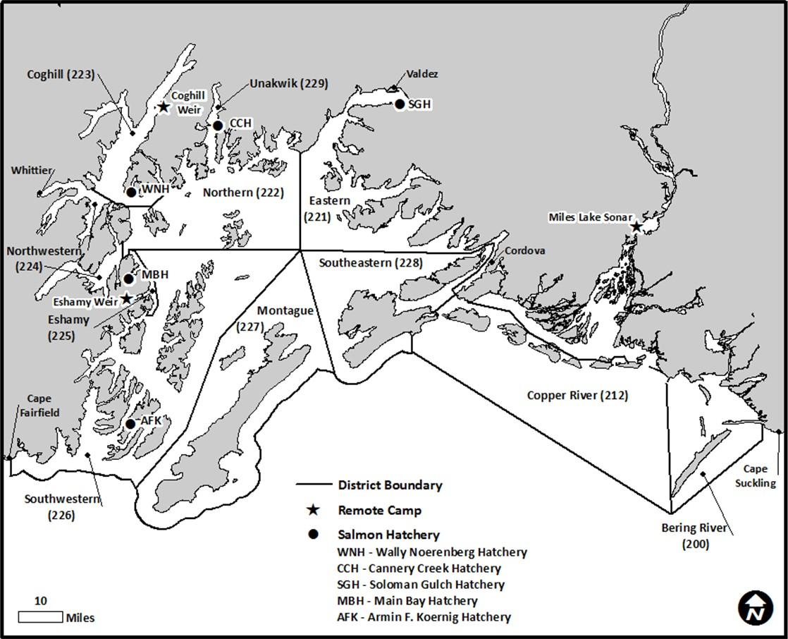

Figure 1.–Prince William Sound Management Area showing commercial fishing districts, salmon hatcheries, weir locations, and Miles Lake sonar camp.

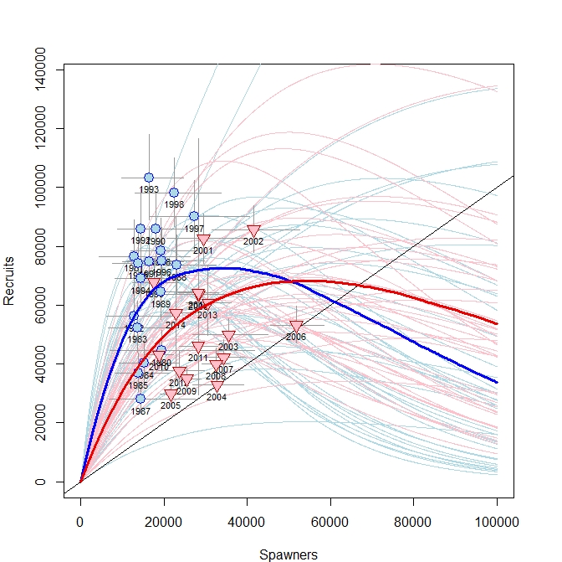

Figure 2. Plausible spawner-recruit relationships for Copper RiverChinook salmon as derived from an age-structured state-space model fitted to abundance, harvest, and age data for 1980–2018 (blue) and 1999-2018 (red). Blue circles indicate pre-1999 data while red triangles indicate data from 1999–2018. Posterior medians of R and S are plotted as brood year labels with 95% credibility intervals plotted as light lines. The heavy red and blue lines are the Ricker relationship constructed from ln(*α*) and *β* posterior medians. Ricker relationships are also plotted (light red and blue lines) for paired values of ln(*α*) and *β* sampled from the posterior probability distribution, representing plausible Ricker relationships that could have generated the observed data. Recruits replace spawners (R = S) on the diagonal line.

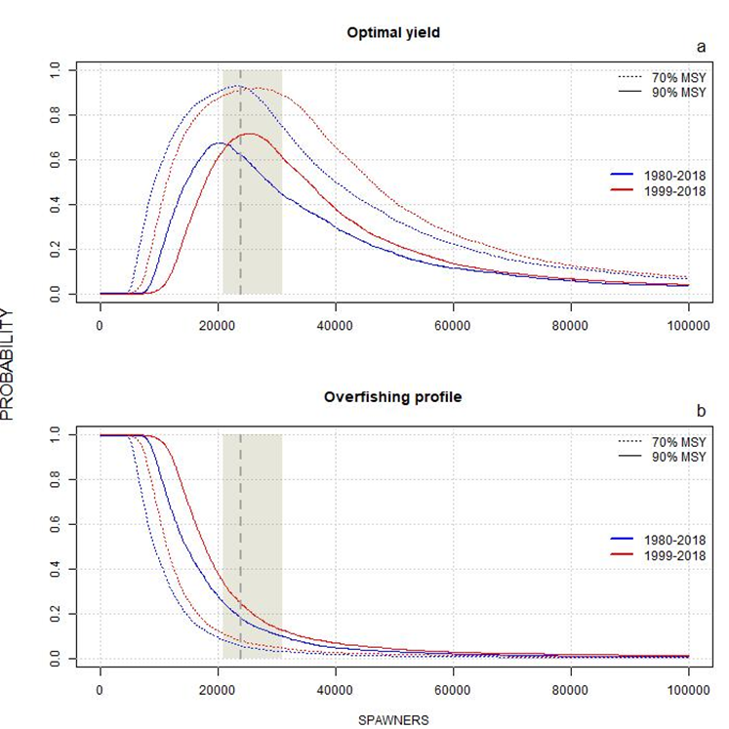

Figure 3. Optimal yield profiles (OYPs) and overfishing profiles (OFPs) for Copper RiverChinook salmon as derived from an age-structured state-space model fitted to abundance, harvest, and age data for 1980–2018 (blue) and 1999–2018 (red). Shaded areas bracket the recommended goal range.

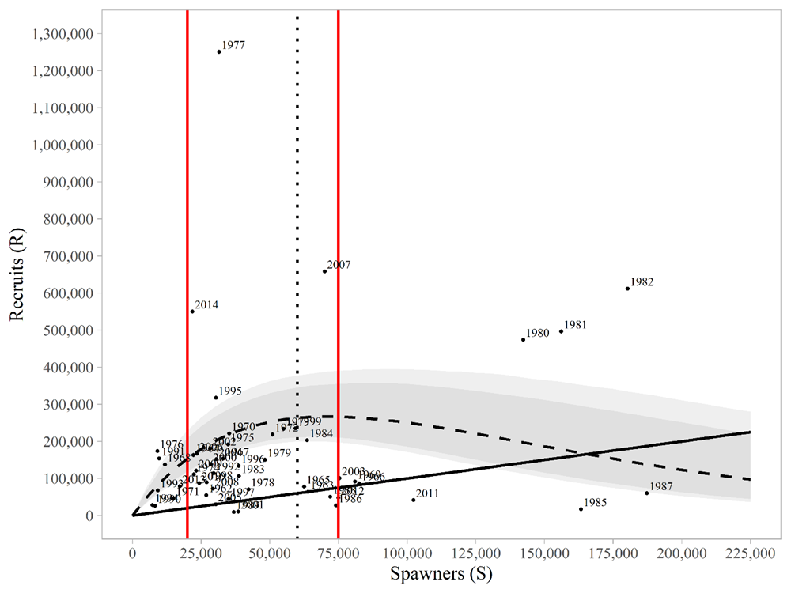

Figure 4.– Modeled spawner-recruit relationships for Coghill Lake sockeye salmon as derived from a Bayesian stock-recruit analysis for brood years 1962–2014. Posterior medians of *R* and *S* are plotted as brood year labels. The heavy dashed line is the Ricker relationship constructed from ln(*α*) and *β* posterior medians with 90% and 95% credibility intervals (shaded areas). Recruits equal spawners on the solid diagonal “replacement” line. The two red vertical lines show the proposed SEG range of 20,000–75,000 spawner, and the dotted black vertical line shows the upper bound of the existing goal (60,000).

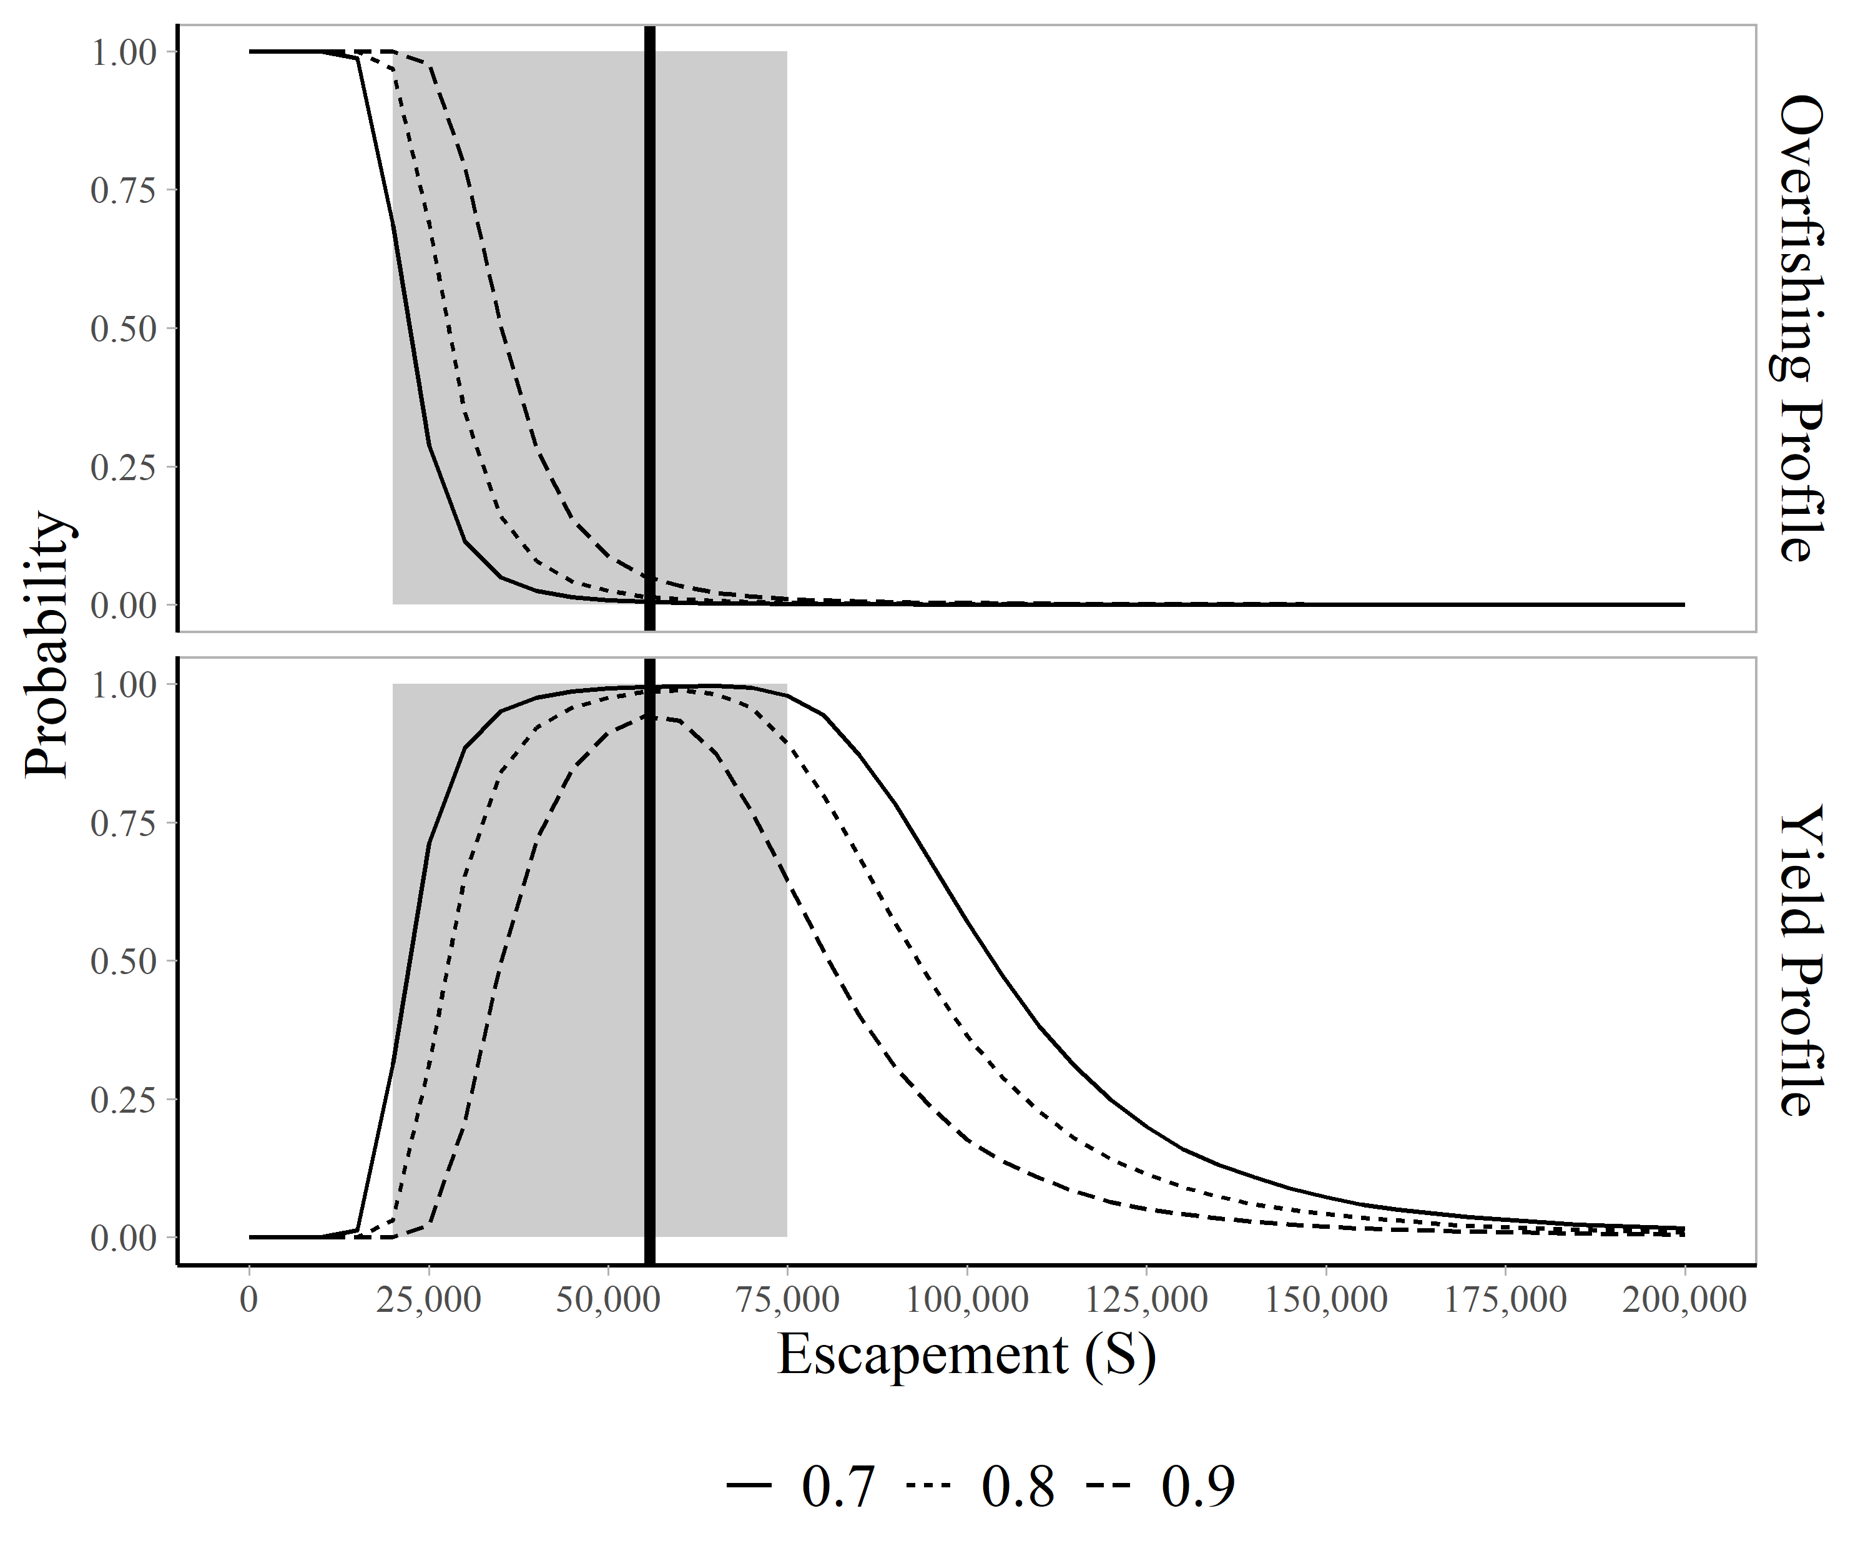

Figure 5.–Overfishing profiles (OFPs), and optimal yield profiles (OYPs) for Coghill Lake sockeye salmon. The OYPs show the probability that an escapement will result in specified fractions (0.70, 0.80, and 0.90 line) of maximum sustained yield. The OFPs show the probability that reducing escapement to a specified level will result in less than specified fractions of maximum sustained yield. The solid vertical line is the posterior median of spawning abundance at maximum sustained yield obtained from the state-space model (*SMSY* = 55,863).

# APPENDIX A: SUPPORTING INFORMATION FOR ESCAPEMENT GOALS FOR SALMON STOCKS IN THE COPPER RIVER, BERING RIVER, AND PRINCE WILLIAM SOUND AREAS

Appendix A 1.–Supporting information for analysis of the escapement goal for Copper River Chinook salmon.

|  |  |  |  |
| --- | --- | --- | --- |
|  | Estimated |  | Total |
| Year | escapement a |  | Runb |
| 1999 | 16,157 |  | 95,951 |
| 2000 | 24,492 |  | 70,754 |
| 2001 | 28,208 |  | 81,139 |
| 2002 | 21,354 |  | 72,974 |
| 2003 | 33,919 |  | 94,555 |
| 2004 | 30,473 |  | 80,566 |
| 2005 | 21,556 |  | 66,357 |
| 2006 | 58,425 |  | 99,877 |
| 2007 | 34,562 |  | 87,771 |
| 2008 | 32,453 |  | 53,893 |
| 2009 | 27,749 |  | 43,007 |
| 2010 | 16,746 |  | 33,184 |
| 2011 | 27,936 |  | 53,890 |
| 2012 | 27,846 |  | 44,313 |
| 2013 | 29,013 |  | 42,902 |
| 2014 | 20,689 |  | 35,322 |
| 2015 | 26,751 |  | 56,187 |
| 2016 | 12,430 |  | 29,295 |
| 2017 | 33,644 |  | 56,167 |
| 2018 | 42,678 |  | 61,631 |

*Note*: Current goal is a lower-bound sustainable escapement goal (SEG) of >24,000 Chinook salmon and a change to a SEG range of 21,000–31,000 is recommended.

a Estimated by mark–recapture minus upriver harvests.

b Estimated as the sum of the inriver run (escapement and inriver harvest) plus the commercial harvest.

Appendix A 2.–Supporting information for analysis of the escapement goal for Bering River District coho salmon.

|  |  |  |  |
| --- | --- | --- | --- |
|  |  |  | Commercial |
| Year | Escapement a |  | Harvestb |
| 1982 | 30,000 |  | 144,752 |
| 1983 | 16,700 |  | 117,669 |
| 1984 | 20,000 |  | 214,632 |
| 1985 | 80,500 |  | 419,276 |
| 1986 | 9,420 |  | 115,809 |
| 1987 | 5,585 |  | 15,864 |
| 1988 | 11,415 |  | 86,539 |
| 1989 | 15,820 |  | 26,952 |
| 1990 | 24,800 |  | 42,952 |
| 1991 | 31,300 |  | 110,951 |
| 1992 | 16,300 |  | 125,616 |
| 1993 | 30,050 |  | 115,833 |
| 1994 | 28,550 |  | 259,003 |
| 1995 | 27,450 |  | 282,045 |
| 1996 | 26,800 |  | 93,763 |
| 1997 | 42,400 |  | 97 |
| 1998 | 29,800 |  | 12,284 |
| 1999 | 31,290 |  | 9,852 |
| 2000 | 26,380 |  | 56,329 |
| 2001 | 30,007 |  | 2,715 |
| 2002 | 34,200 |  | 108,522 |
| 2003 | 32,475 |  | 59,481 |
| 2004 | 30,185 |  | 95,595 |
| 2005 | 44,542 |  | 43,030 |
| 2006 | 33,192 |  | 56,713 |
| 2007 | 32,962 |  | 9,305 |
| 2008 | 28,822 |  | 40,380 |
| 2009 | 21,760 |  | 45,522 |
| 2010 | 21,311 |  | 80,560 |
| 2011 | 18,890 |  | 19,956 |
| 2012 | 15,605 |  | 46,169 |
| 2013 | 18,820 |  | 46,959 |
| 2014 | 26,475 |  | 97,637 |
| 2015 | 15,550 |  | 12,106 |
| 2016 | 26,150 |  | 80,094 |
| 2017 | 30,650 |  | 119,090 |
| 2018 | 26,525 |  | 120,774 |

Appendix A2.–Page 2 of 2.

|  |
| --- |
|  |

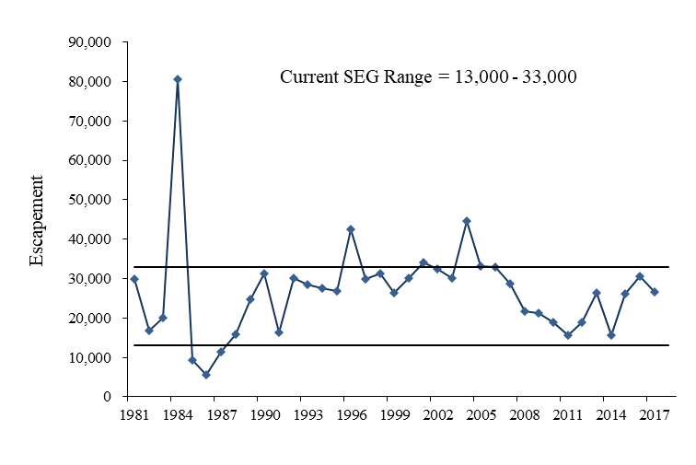

Appendix A 3.–Supporting information for analysis of the escapement goal for Copper River Delta coho salmon.

|  |  |  |  |  |
| --- | --- | --- | --- | --- |
|  |  |  | Harvest |  |
| Year | Escapement a |  | Commercial b | Sport c |
| 1981 | 44,800 |  | 310,154 | 0 |
| 1982 | 40,575 |  | 454,763 | 398 |
| 1983 | 60,050 |  | 234,243 | 84 |
| 1984 | 64,525 |  | 382,432 | 1,780 |
| 1985 | 106,410 |  | 587,990 | 649 |
| 1986 | 25,790 |  | 295,980 | 2,969 |
| 1987 | 26,465 |  | 111,599 | 1,010 |
| 1988 | 26,560 |  | 315,568 | 1,492 |
| 1989 | 40,856 |  | 194,454 | 2,118 |
| 1990 | 41,281 |  | 246,797 | 1,778 |
| 1991 | 63,656 |  | 385,086 | 1,941 |
| 1992 | 44,013 |  | 291,627 | 3,854 |
| 1993 | 31,870 |  | 281,469 | 4,139 |
| 1994 | 43,955 |  | 677,633 | 4,293 |
| 1995 | 34,480 |  | 542,658 | 2,543 |
| 1996 | 46,110 |  | 193,042 | 6,364 |
| 1997 | 55,360 |  | 18,656 | 2,825 |
| 1998 | 42,200 |  | 108,232 | 4,230 |
| 1999 | 43,725 |  | 153,061 | 6,978 |
| 2000 | 42,830 |  | 304,944 | 4,479 |
| 2001 | 40,496 |  | 251,473 | 12,144 |
| 2002 | 87,415 |  | 504,223 | 6,909 |
| 2003 | 72,055 |  | 363,489 | 14,443 |
| 2004 | 99,505 |  | 467,859 | 14,643 |
| 2005 | 99,682 |  | 263,465 | 9,799 |
| 2006 | 89,070 |  | 318,285 | 5,531 |
| 2007 | 51,215 |  | 117,182 | 6,749 |
| 2008 | 74,772 |  | 202,621 | 7,763 |
| 2009 | 40,124 |  | 207,776 | 14,420 |
| 2010 | 40,377 |  | 210,621 | 15,866 |
| 2011 | 38,145 |  | 127,511 | 14,304 |
| 2012 | 36,735 |  | 130,261 | 15,230 |
| 2013 | 34,630 |  | 244,985 | 17,053 |
| 2014 | 44,040 |  | 315,776 | 16,226 |
| 2015 | 42,065 |  | 136,981 | 24,515 |
| 2016 | 76,200 |  | 367,630 | 13,094 |
| 2017 | 43,760 |  | 306,287 | 9,582 |
| 2018 | 53,800 |  | 303,957 | 12,117 |

a Escapement indices calculated as peak aerial survey from the 18 primary index systems.

b Copper River District harvest, not stock specific.

c From statewide harvest survey. The sport harvest includes both upriver and Copper River Delta harvests.

-continued-

Appendix A3.**–**Page 2 of 2.

Appendix A 4.–Supporting information for analysis of the escapement goal for Bering River District sockeye salmon.

|  |  |  |
| --- | --- | --- |
|  |  | Commercial |
| Year | Escapement a | Harvest b |
| 1988 | 13,680 | 7,152 |
| 1989 | 23,300 | 9,225 |
| 1990 | 19,741 | 8,332 |
| 1991 | 32,220 | 19,181 |
| 1992 | 55,895 | 19,721 |
| 1993 | 27,725 | 33,951 |
| 1994 | 26,550 | 27,926 |
| 1995 | 33,450 | 21,585 |
| 1996 | 27,310 | 37,712 |
| 1997 | 15,065 | 9,651 |
| 1998 | 23,450 | 8,439 |
| 1999 | 46,195 | 13,697 |
| 2000 | 24,220 | 1,279 |
| 2001 | 8,823 | 5,450 |
| 2002 | 24,715 | 235 |
| 2003 | 49,840 | 18,266 |
| 2004 | 25,135 | 13,165 |
| 2005 | 30,890 | 77,465 |
| 2006 | 14,671 | 36,867 |
| 2007 | 21,170 | 16,470 |
| 2008 | 18,196 | 1,175 |
| 2009 | 13,471 | 4,157 |
| 2010 | 4,367 | 51 |
| 2011 | 28,530 | 6 |
| 2012 | 18,290 | 0 |
| 2013 | 23,900 | 3,321 |
| 2014 | 14,885 | 50 |
| 2015 | 22,705 | 2,137 |
| 2016 | 16,390 | 9,840 |
| 2017 | 19,115 | 2,578 |
| 2018 | 13,300 | 33 |

a Escapement indices calculated as the sum of peak aerial index counts from 6 primary index systems

b Bering River District harvest, not stock specific.

-continued-

Appendix A4.**–**Page 2 of 2.

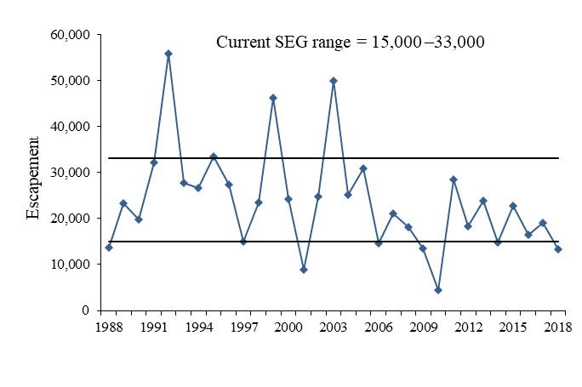

Appendix A5.**–**Supporting information for analysis of escapement goal for Upper Copper River sockeye salmon.

|  |  |  |  |  |  |
| --- | --- | --- | --- | --- | --- |
|  | Wild |  |  | Harvest b | |
| Year a | Escapement a |  | Commercial | Sport | Sub/PU |
| 1979 | 251,903 |  | 79,628 | 1,599 | 33,096 |
| 1980 | 295,346 |  | 18,558 | 2,109 | 31,041 |
| 1981 | 496,244 |  | 474,062 | 1,523 | 67,897 |
| 1982 | 395,719 |  | 1,174,032 | 3,343 | 108,611 |
| 1983 | 458,405 |  | 620,135 | 2,619 | 116,988 |
| 1984 | 499,792 |  | 894,725 | 3,267 | 76,177 |
| 1985 | 359,971 |  | 895,598 | 4,752 | 61,551 |
| 1986 | 361,591 |  | 749,795 | 4,137 | 68,495 |
| 1987 | 384,603 |  | 1,133,273 | 4,876 | 76,620 |
| 1988 | 389,150 |  | 484,654 | 3,038 | 71,525 |
| 1989 | 477,667 |  | 850,358 | 4,509 | 84,138 |
| 1990 | 472,978 |  | 779,861 | 3,569 | 98,197 |
| 1991 | 387,196 |  | 1,104,802 | 5,511 | 117,189 |
| 1992 | 406,255 |  | 883,818 | 4,560 | 131,956 |
| 1993 | 538,602 |  | 1,248,390 | 5,288 | 146,884 |
| 1994 | 461,315 |  | 1,057,564 | 6,533 | 163,299 |
| 1995 | 376,565 |  | 1,123,978 | 6,068 | 131,538 |
| 1996 | 546,131 |  | 2,029,032 | 11,851 | 147,059 |
| 1997 | 756,179 |  | 2,675,630 | 12,293 | 231,961 |
| 1998 | 462,396 |  | 812,561 | 11,184 | 202,206 |
| 1999 | 449,892 |  | 734,627 | 11,101 | 219,082 |
| 2000 | 343,691 |  | 512,817 | 12,361 | 167,353 |
| 2001 | 538,681 |  | 1,127,251 | 8,169 | 215,957 |
| 2002 | 579,598 |  | 910,966 | 7,761 | 147,670 |
| 2003 | 505,008 |  | 1,028,868 | 7,108 | 145,187 |
| 2004 | 443,340 |  | 980,091 | 6,464 | 187,040 |
| 2005 | 516,555 |  | 1,234,770 | 8,135 | 209,007 |
| 2006 | 578,720 |  | 1,268,973 | 14,297 | 201,708 |
| 2007 | 611,648 |  | 1,800,234 | 23,028 | 209,947 |
| 2008 | 481,167 |  | 299,207 | 11,431 | 139,381 |
| 2009 | 468,819 |  | 833,154 | 13,415 | 151,705 |
| 2010 | 502,445 |  | 412,828 | 14,743 | 226,362 |
| 2011 | 607,140 |  | 1,558,858 | 7,727 | 205,884 |
| 2012 | 954,010 |  | 1,516,771 | 23,404 | 220,694 |
| 2013 | 860,253 |  | 1,254,143 | 26,711 | 275,246 |
| 2014 | 864,169 |  | 1,679,370 | 18,005 | 258,357 |
| 2015 | 930,145 |  | 1,583,601 | 9,489 | 334,037 |
| 2016 | 513,143 |  | 1,000,670 | 7,555 | 232,562 |
| 2017 | 460,295 |  | 547,167 | 9,589 | 194,507 |
| 2018 | 495,779 |  | 40,349 | 2,943 | 136,576 |
| 2019 | 719,526 |  | 1,210,566 | 7,346 | 257,316 |

*Note*: Sub = subsistence fisheries, PU = personal use fisheries.

a Wild spawning escapements after 1978 were estimated as the adjusted Miles Lake sonar index (in DIDSON units) minus subsistence, personal use, and sport harvests and minus the Gulkana Hatchery broodstock and excess brood escapement.

b Sport and subsistence/personal use harvests include wild and hatchery stocks. Prior to 1995, no stock identification data were collected in subsistence or personal use fisheries.

Appendix A5.**–**Page 2 of 2.

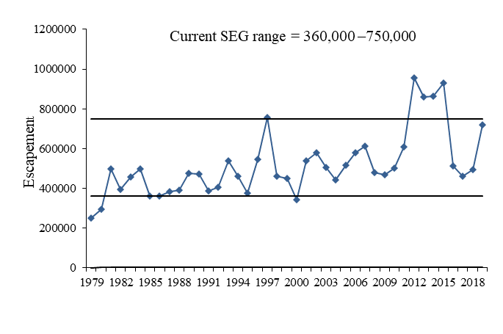

Appendix A6.–Supporting information for analysis of escapement goal for Copper River Delta sockeye salmon.

|  |  |
| --- | --- |
| Year | Escapement a |
| 1971 | 73,587 |
| 1972 | 78,942 |
| 1973 | 40,970 |
| 1974 | 27,993 |
| 1975 | 40,910 |
| 1976 | 54,500 |
| 1977 | 55,144 |
| 1978 | 83,469 |
| 1979 | 127,900 |
| 1980 | 156,950 |
| 1981 | 141,550 |
| 1982 | 106,770 |
| 1983 | 115,750 |
| 1984 | 168,840 |
| 1985 | 142,050 |
| 1986 | 75,295 |
| 1987 | 60,698 |
| 1988 | 53,315 |
| 1989 | 51,700 |
| 1990 | 73,345 |
| 1991 | 90,500 |
| 1992 | 76,827 |
| 1993 | 57,720 |
| 1994 | 78,370 |
| 1995 | 76,370 |
| 1996 | 65,470 |
| 1997 | 72,563 |
| 1998 | 87,500 |
| 1999 | 100,925 |
| 2000 | 98,045 |
| 2001 | 71,065 |
| 2002 | 75,735 |
| 2003 | 73,150 |
| 2004 | 69,385 |
| 2005 | 58,406 |
| 2006 | 98,896 |
| 2007 | 88,285 |
| 2008 | 67,950 |
| 2009 | 69,292 |
| 2010 | 83,905 |
| 2011 | 72,367 |
| 2012 | 66,850 |
| 2013 | 75,705 |
| 2014 | 64,205 |
| 2015 | 66,665 |
| 2016 | 51,550 |
| 2017 | 56,950 |
| 2018 | 58,470 |
| 2019 | 61,825 |

a Escapement indices calculated as the peak aerial counts from 18 survey sites.

Appendix A6.**–**Page 2 of 2.

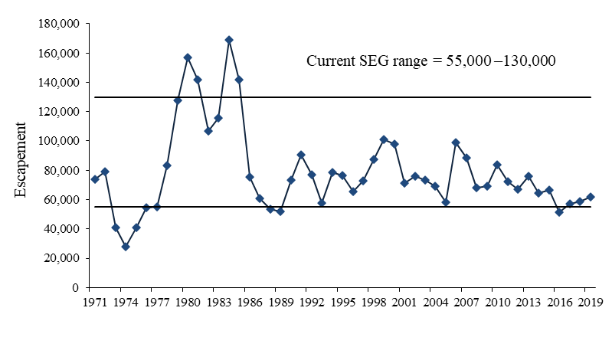

Appendix A7.–Supporting information for analysis of escapement goal for Eshamy Lake sockeye salmon.

|  |  |  |  |  |
| --- | --- | --- | --- | --- |
| Brood | Wild | BY Total |  |  |
| Year | Escapement | Return a | R/S | Yield b |
| 1970 | 11,460 | 11,690 | 1.02 | 230 |
| 1971 | 954 | 6,667 | 6.99 | 5,713 |
| 1972 | 28,683 | 59,976 | 2.09 | 31,293 |
| 1973 | 10,202 | 34,411 | 3.37 | 24,209 |
| 1974 | 633 | 15,946 | 25.19 | 15,313 |
| 1975 | 1,724 | 31,355 | 18.19 | 29,631 |
| 1976 | 19,367 | 178,061 | 9.19 | 158,694 |
| 1977 | 11,746 | 38,453 | 3.27 | 26,707 |
| 1978 | 12,580 | 36,904 | 2.93 | 24,324 |
| 1979 | 12,169 | 39,724 | 3.26 | 27,555 |
| 1980 | 44,263 | 270,623 | 6.11 | 226,360 |
| 1981 | 23,048 | 30,841 | 1.34 | 7,793 |
| 1982 | 6,782 | 51,290 | 7.56 | 47,490 |
| 1983 | 10,348 | 51,162 | 4.94 | 43,355 |
| 1984 | 36,121 | 117,761 | 3.26 | 81,012 |
| 1985 | 26,178 | 58,163 | 2.22 | 31,960 |
| 1986 | 6,949 | 39,946 | 5.75 | 32,997 |
| 1987 c | NA | NA | NA | NA |
| 1988 | 31,747 | 93,876 | 3.0 | 62,129 |
| 1989 | 57,106 | 70,390 | 1.2 | 13,284 |
| 1990 | 14,191 | 58,447 | 4.1 | 44,256 |
| 1991 | 45,814 | 23,930 | 0.5 | -21,884 |
| 1992 | 30,627 | 24,468 | 0.8 | -6,110 |
| 1993 | 34,657 | 61,820 | 1.8 | 29,802 |
| 1994 | 23,910 | 54,750 | 2.3 | 33,382 |
| 1995 | 15,292 | 27,986 | 1.8 | 12,630 |
| 1996 | 5,271 | 65,804 | 12.5 | 60,533 |
| 1997 | 41,299 | 64,513 | 1.6 | 23,214 |
| 1998 c | NA | 91,903 | NA | NA |
| 1999 | 27,057 | 40,521 | 1.5 | 13,464 |
| 2000 | 22,153 | 51,753 | 2.3 | 29,600 |
| 2001 | 55,187 | 50,750 | 0.9 | -4,437 |
| 2002 | 40,478 | 62,834 | 1.6 | 22,356 |
| 2003 | 39,845 | 20,147 | 0.5 | -19,698 |
| 2004 | 13,443 | 53,477 | 4.0 | 40,034 |
| 2005 | 23,523 | 41,261 | 1.8 | 17,738 |
| 2006 | 42,473 | 62,674 | 1.5 | 20,201 |
| 2007d | 17,196 | NA | NA | NA |
| 2008d | 18,495 | NA | NA | NA |
| 2009d | 24,025 | NA | NA | NA |
| 2010d | 16,291 | NA | NA | NA |
| 2011d | 24,129 | NA | NA | NA |
| 2012-2019c | NA | NA | NA | NA |

*Note:* Current goal is a biological escapement goal (BEG) of 13,000–28,000 sockeye salmon and no change to the goal is recommended. BY= brood year, R/S = return per spawner.

a Total return was calculated as the wild escapement contribution estimates plus the Eshamy and Southwestern districts wild stock harvests as estimated from otolith analysis minus hatchery contribution estimates from sockeye salmon returning to Main Bay Hatchery and the estimate of Coghill Lake sockeye salmon in the harvest.

b Calculated as total return minus brood year escapement.

c Eshamy Lake weir was not in place in 1987, 1998, or 2012.

d Complete return data not available to calculate BY total return, R/S, or yield.

Appendix A8–Supporting information for analysis of escapement goals for Prince William Sound chum salmon.

|  |  |  |  |  |  |
| --- | --- | --- | --- | --- | --- |
|  | Escapements a | | | | |
| Year | Eastern | Northern | Coghill | Northwestern | Southeastern |
| 1980 | 20,198 | 18,544 | 21,165 | 1,419 | 7,829 |
| 1981 | 65,913 | 37,442 | 1,000 | 10,302 | 14,933 |
| 1982 | 124,757 | 70,698 | 14,368 | 8,345 | 17,262 |
| 1983 | 120,689 | 91,188 | 55,119 | 32,022 | 17,240 |
| 1984 | 106,352 | 62,128 | 12,094 | 4,645 | 3,577 |
| 1985 | 32,743 | 30,068 | 15,656 | 11,052 | 2,220 |
| 1986 | 143,518 | 63,518 | 17,604 | 20,878 | 13,909 |
| 1987 | 189,502 | 34,388 | 19,654 | 32,807 | 44,617 |
| 1988 | 313,522 | 98,884 | 57,921 | 54,072 | 89,549 |
| 1989 | 126,836 | 55,440 | 21,240 | 30,827 | 23,093 |
| 1990 | 127,676 | 116,265 | 19,588 | 31,340 | 7,181 |
| 1991 | 60,686 | 19,954 | 5,572 | 8,211 | 7,692 |
| 1992 | 43,953 | 15,189 | 7,677 | 12,107 | 3,559 |
| 1993 | 55,691 | 24,863 | 9,642 | 19,810 | 23,555 |
| 1994 | 45,947 | 27,949 | 18,178 | 14,633 | 4,108 |
| 1995 | 96,443 | 38,405 | 15,258 | 6,575 | 25,417 |
| 1996 | 182,383 | 73,362 | 26,703 | 33,143 | 36,971 |
| 1997 | 108,477 | 25,133 | 3,822 | 10,867 | 49,101 |
| 1998 | 87,383 | 28,855 | 13,278 | 5,552 | 32,365 |
| 1999 | 163,516 | 36,727 | 6,426 | 4,748 | 26,164 |
| 2000 | 198,132 | 31,074 | 26,540 | 10,145 | 40,448 |
| 2001 | 250,878 | 93,667 | 18,033 | 7,613 | 38,322 |
| 2002 | 116,992 | 38,763 | 9,560 | 21,427 | 91,469 |
| 2003 | 258,516 | 55,648 | 23,839 | 14,747 | 102,106 |
| 2004 | 146,246 | 47,487 | 11,614 | 13,040 | 50,507 |
| 2005 | 160,064 | 36,641 | 13,571 | 13,994 | 11,471 |
| 2006 | 136,562 | 56,259 | 23,465 | 22,710 | 34,085 |
| 2007 | 140,595 | 51,168 | 13,757 | 11,499 | 59,199 |
| 2008 | 79,450 | 49,595 | 48,008 | 33,635 | 18,142 |
| 2009 | 146,577 | 29,464 | 7,763 | 15,730 | 123,607 |
| 2010 | 140,940 | 58,029 | 84,752 | 34,131 | 80,927 |
| 2011 | 237,372 | 63,876 | 19,614 | 11,951 | 107,857 |
| 2012 | 94,986 | 23,273 | 13,896 | 9,360 | 28,374 |
| 2013 | 146,349 | 40,475 | 14,086 | 4,995 | 33,678 |
| 2014 | 90,445 | 27,385 | 9,491 | 5,041 | 29,362 |
| 2015 | 104,437 | 41,253 | 14,929 | 7,060 | 44,095 |
| 2016 | 116,685 | 10,410 | 976 | 3,954 | 13,919 |
| 2017 | 76,836 | 33,437 | 13,210 | 7,118 | 26,330 |
| 2018 | 109,598 | 18,407 | 13,617 | 15,563 | 10,164 |
| 2019 | 56,846 | 11,690 | 3,437 | 3,258 | 19,451 |
| aThe chum salmon escapement index is the area under the curve of weekly aerial survey counts of 134 index streams adjusted for stream life (adjusted AUC). Escapement estimates for streams with 3 or more surveys per year only. | | | | | |

Appendix A9.–Supporting information for analysis of escapement goals for Prince William Sound even-year pink salmon.

|  |  |  |  |  |  |  |  |  |  |
| --- | --- | --- | --- | --- | --- | --- | --- | --- | --- |
| Year | Eastern | Northern/Unakwik | Coghill | Northwestern | Eshamy | Southwestern | Montague | Southeastern | Total |
| 1982 | 333,392 | 139,533 | 188,841 | 93,998 | 288 | 55,611 | 42,506 | 186,455 | 1,040,624 |
| 1984 | 839,339 | 353,175 | 232,592 | 367,782 | NA | 246,298 | 89,130 | 396,810 | 2,525,125 |
| 1986 | 266,051 | 125,507 | 89,825 | 65,328 | 3,690 | 59,630 | 24,939 | 87,771 | 722,741 |
| 1988 | 283,057 | 98,261 | 34,004 | 82,126 | NA | 126,318 | 50,927 | 86,037 | 760,729 |
| 1990 | 320,285 | 103,386 | 36,181 | 110,549 | 27,731 | 155,093 | 73,511 | 162,204 | 988,938 |
| 1992 | 150,193 | 61,195 | 18,324 | 46,766 | 4,310 | 69,782 | 38,170 | 64,113 | 452,851 |
| 1994 | 485,152 | 143,478 | 55,116 | 168,058 | 12,604 | 135,104 | 35,114 | 116,949 | 1,151,575 |
| 1996 | 450,974 | 148,585 | 63,240 | 76,696 | 2,207 | 63,175 | 58,570 | 116,870 | 980,319 |
| 1998 | 246,423 | 127,375 | 42,434 | 51,978 | 2,852 | 333,787 | 109,016 | 88,655 | 1,002,519 |
| 2000 | 360,133 | 107,466 | 137,665 | 54,523 | 2,772 | 97,918 | 114,597 | 158,708 | 1,033,782 |
| 2002 | 119,689 | 77,126 | 26,572 | 32,839 | 1,157 | 33,847 | 33,121 | 143,375 | 467,726 |
| 2004 | 534,679 | 107,478 | 49,050 | 39,153 | 1,364 | 111,427 | 128,553 | 314,418 | 1,286,122 |
| 2006 | 192,217 | 134,672 | 123,881 | 90,347 | 8,056 | 70,426 | 94,143 | 129,858 | 843,600 |
| 2008 | 161,710 | 121,502 | 142,733 | 138,968 | 579 | 61,820 | 51,571 | 85,869 | 764,753 |
| 2010 | 437,191 | 244,810 | 328,447 | 207,490 | 9,261 | 109,012 | 129,968 | 223,178 | 1,689,357 |
| 2012 | 268,432 | 91,211 | 170,752 | 114,518 | 1,052 | 79,774 | 70,695 | 213,071 | 1,009,505 |
| 2014 | 250,381 | 95,643 | 60,921 | 66,350 | 12,167 | 73,104 | 23,136 | 141,845 | 723,548 |
| 2016 | 594,778 | 135,037 | 63,986 | 168,272 | NA | NA | NA | 107,769 | 1,071,192 |
| 2018 | 309,325 | 113,384 | 70,881 | 111,194 | 16,594 | 81,100 | 135,208 | 293,275 | 1,130,961 |
| *Notes*: The pink salmon escapement index is the area under the curve of weekly aerial survey counts of 134 index streams adjusted for stream life (adjusted AUC). Escapement estimates for streams with 3 or more surveys per year only. | | | | | | | | | |

Appendix A10 –Supporting information for analysis of escapement goals for Prince William Sound odd-year pink salmon.

|  |  |  |  |  |  |  |  |  |  |
| --- | --- | --- | --- | --- | --- | --- | --- | --- | --- |
| Year | Eastern | Northern/Unakwik | Coghill | Northwestern | Eshamy | Southwestern | Montague | Southeastern | Total |
| 1981 | 543,023 | 221,272 | 87,281 | 58,123 | NA | 106,757 | 176,488 | 199,729 | 1,392,673 |
| 1983 | 347,486 | 127,242 | 191,220 | 147,170 | NA | 91,123 | 105,172 | 284,749 | 1,294,162 |
| 1985 | 598,507 | 166,714 | 179,321 | 145,410 | NA | 104,184 | 202,946 | 378,249 | 1,775,331 |
| 1987 | 421,972 | 109,380 | 36,410 | 77,296 | NA | 137,040 | 120,511 | 239,862 | 1,142,471 |
| 1989 | 250,082 | 101,436 | 37,487 | 81,846 | 34,600 | 212,757 | 126,294 | 205,178 | 1,049,680 |
| 1991 | 345,169 | 114,718 | 68,899 | 83,940 | 33,941 | 169,162 | 132,545 | 373,277 | 1,321,651 |
| 1993 | 315,598 | 96,955 | 38,498 | 61,353 | 20,700 | 130,824 | 140,902 | 289,492 | 1,094,323 |
| 1995 | 402,264 | 84,312 | 49,310 | 54,656 | 8,990 | 111,495 | 165,572 | 261,894 | 1,138,494 |
| 1997 | 322,445 | 50,427 | 48,374 | 49,982 | 853 | 92,913 | 158,475 | 437,989 | 1,161,458 |
| 1999 | 310,051 | 126,575 | 147,845 | 45,282 | 4,795 | 153,763 | 237,219 | 372,836 | 1,398,366 |
| 2001 | 424,655 | 144,113 | 157,927 | 126,442 | 4,413 | 237,739 | 299,577 | 367,359 | 1,762,225 |
| 2003 | 964,355 | 253,962 | 370,688 | 108,073 | 6,954 | 136,902 | 304,685 | 485,550 | 2,631,169 |
| 2005 | 1,109,422 | 613,712 | 553,954 | 430,024 | 69,175 | 340,708 | 540,669 | 1,265,986 | 4,923,650 |
| 2007 | 424,938 | 169,596 | 238,770 | 72,040 | 11,727 | 115,112 | 149,881 | 448,990 | 1,631,054 |
| 2009 | 700,027 | 152,979 | 147,498 | 137,036 | 12,966 | 258,404 | 338,998 | 524,415 | 2,272,323 |
| 2011 | 916,690 | 156,362 | 217,560 | 139,334 | 3,643 | 188,475 | 489,313 | 1,138,410 | 3,249,789 |
| 2013 | 1,266,630 | 299,592 | 625,991 | 201,836 | 12,145 | 337,952 | 365,807 | 1,137,736 | 4,247,690 |
| 2015 | 1,440,254 | 708,920 | 775,488 | 438,944 | 68,988 | 644,158 | 559,994 | 1,529,543 | 6,166,289 |
| 2017 | 557,545 | 395,437 | 181,153 | 250,989 | 2,836 | 172,930 | 205,252 | 372,960 | 2,139,101 |
| 2019 | 445,075 | 195,169 | 153,129 | 91,267 | 1,402 | 33,340 | 25,385 | 290,452 | 1,235,219 |
| *Notes*: The pink salmon escapement index is the area under the curve of weekly aerial survey counts of 134 index streams adjusted for stream life (adjusted AUC). Escapement estimates for streams with 3 or more surveys per year only. | | | | | | | | | |